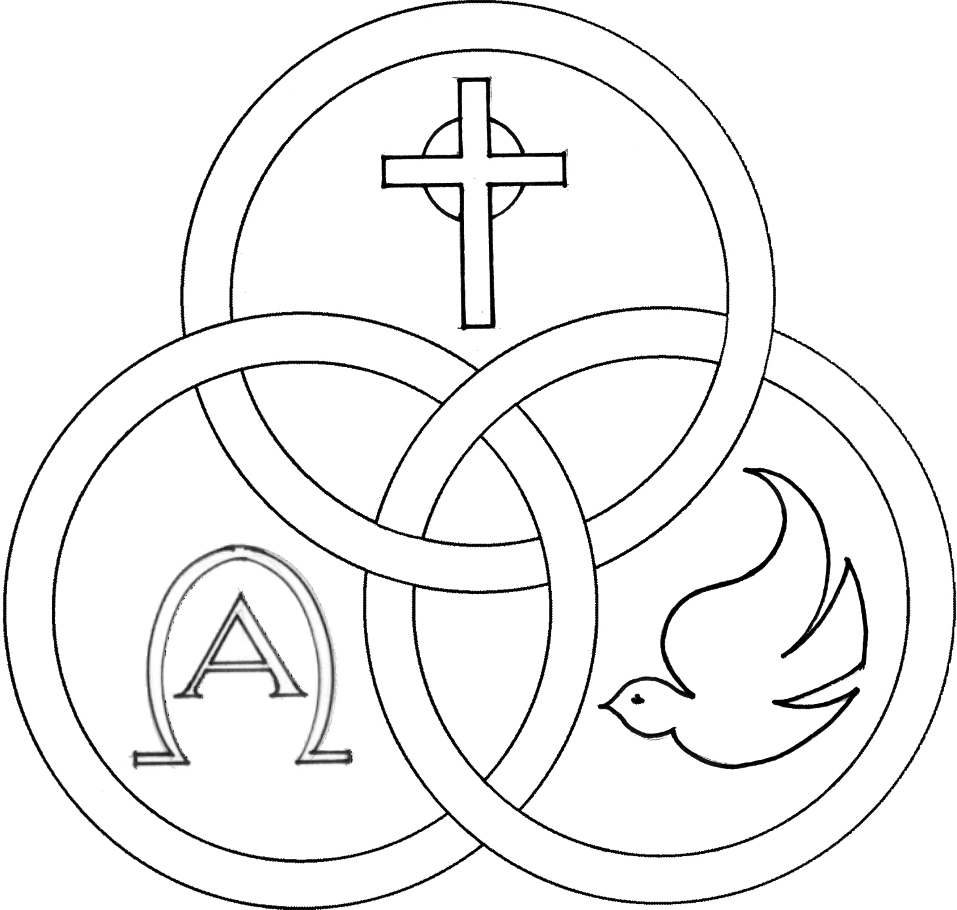
Parish of the Holy Trinity Roman Catholic Church
951Stafford Road
Fall River, Massachusetts
www.holytrinityfallriver.com

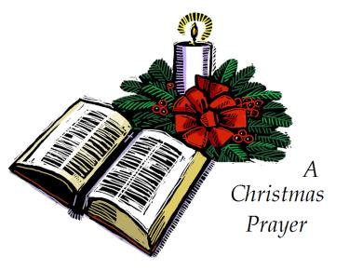
Feast: Baptism of the Lord

Saturday 1/10 Feast: Baptism of the Lord
4:00 pm Francis & Laura Arruda (by Jan & Mike)
Sunday 1/ 11 Feast: Baptism of the Lord
8:30 am Odilia Andrade Birthday Remembrance (by Family)
10:30 am Albert Beaudoin (by Dumont Family)

Monday 1/12 Weekday
8:30 am Larry Roies 2nd Anniversary (by sister Cindy)
Tuesday 1/13 Weekday
8:30 am Raymond Mello & Oliveira Family
Wednesday 1/14 Weekday
8:30 am Jamie DaPonte
Thursday 1/15 Weekday
8:30 am For the People of our parish

Saturday 1/17 2nd Sunday in Ordinary Time
4:00 pm Frank & Olive Medeiros (by Family)
Sunday 1/18 2nd Sunday in Ordinary Time
8:30 am M/M Clementino Oliveira (by Daughters)
10:30 am Rev. David Andrade

Blessed Sacrament Sanctuary Lamp:
Given this week in memory of

Mary Botelho

By Family

Week of 1/4/26

Budget $3,795.00

Snow Removal $2,164.00


Yellow registration forms are available on the tables inside Church, near each of the entrances. Please drop them into the collection basket at Mass and introduce yourself to Father Oliveira after Mass or call the parish office for an appointment. We hope that you feel very much at home!
FROM THE PASTOR THANK YOU to the many people for your Christmas wishes and blessings and for the cards, gifts and goodies. They were greatly appreciated.

THANKS TO ALL our parishioners and friends who generously donated $8,130.00 for the Christmas collection for our parish. Thank you for your Christmas gift to our parish and thank you for your faithful support throughout the year.

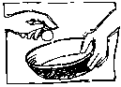
THE SECOND COLLECTION this weekend is the monthly collection for maintenance and expense reduction for our parish. Thank you for all your generosity.

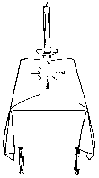
PLEASE REMEMBER IN YOUR PRAYERS Lucille Levesque and Richard McAndrew whose funerals were celebrated in our parish. We extend our prayerful support to their families and friends. May their souls and the souls of all the faithful departed, through the Mercy of God rest in peace. Amen.


THE CHRISTMAS SEASON will conclude this Sunday, January 11th, the feast of the Baptism of the Lord. May our celebration of Christ’s birth enable us to welcome the God who dwells among us!


FOR ALL THOSE WHO WOULD LIKE a plant from our Christmas display, they will be available after the 10:30am Mass THIS Sunday. Plants will be distributed right after Mass on a first come/first serve basis. For reasons of good order and fairness we ask that all those who would like a plant, please be seated in the pews directly in front of the Lectern and a plant will be brought to you.


HOLY TRINITY YOUTH CHOIR: This Sunday, January 11th the Holy Trinity Youth Choir will be singing at the 10:30am Mass.


RELIGIOUS EDUCATION We wish all our students, their families and our Catechists all the Blessings of this Holy Season. Classes resume this Sunday, January 11th 2026.


THANK YOU A VERY SPECIAL THANKS to our women’s guild who has given a $3,700.00 gift to our parish. With the fundraisers our guild has been able to raise some much needed funds for our parish. We thank all the officers and members of our guild for their very generous gift, as well as, for all their hard work and effort. We are most appreciative to them for all that they do for our parish. Thanks also to the members of our parish family that have supported the activities of Holy Trinity Women’s Guild.


HOLY TRINITY PARISH SOUP KITCHEN will be held on Thursday, January 15th in our Church Hall. We welcome everyone to come and share a meal with us. Doors open at 5:00pm and close at 6:00pm. Please share the word that all are most welcome to come.

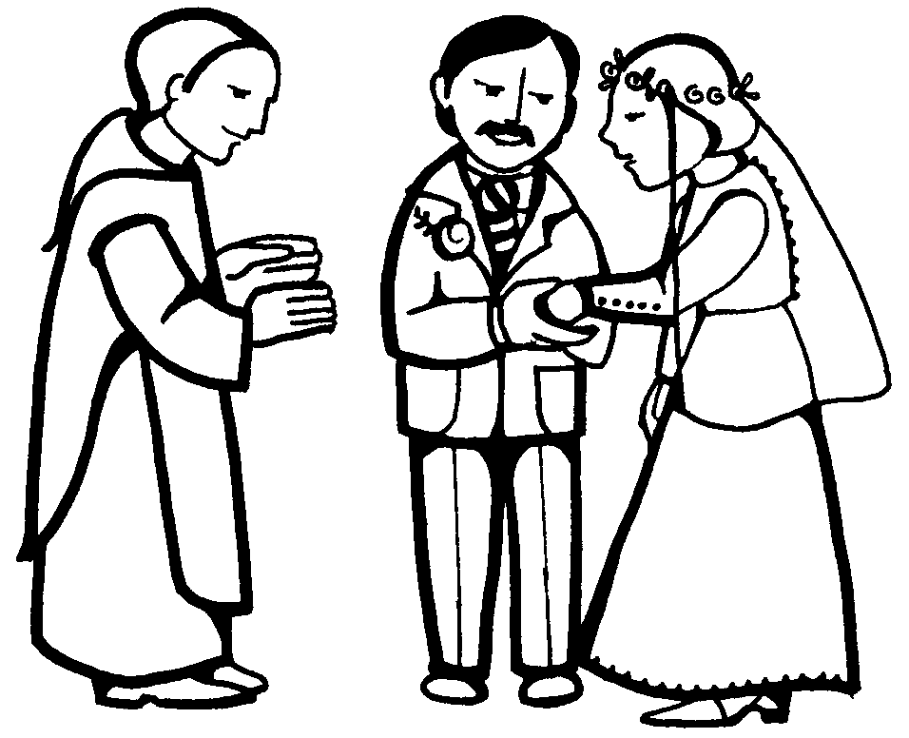
WEDDING ANNIVERSARY CELEBRATION: The Annual Diocesan Wedding Anniversary Celebration will be celebrated with a special Mass of Thanksgiving for couples observing significant wedding anniversaries (including first year). Renew your wedding vows with the Bishop of Fall River on Sunday, February 8, 2026, at 3:00 p.m. at St. Mary Cathedral in Fall River. If you would like an invitation, please call the parish office as soon as possible. The registration deadline for this event is January 13, 2026.

A CHRTISTMAS FLOWER MEMORIAL for those names who did not make it on our memorial bulletin a page has been added that can be inserted into the 2025 memorial. Copies of this memorial can be found at all the entrances of Church.

THIS WEEK’S REFLECTION: In this first week of Ordinary Time, we might find ourselves feeling a little let-down after the Christmas season, especially in parts of the world where it seems cold and dark most days. This is where we can ask for the grace to let the stories of the gospels come alive in our hearts. The vivid narratives of this week’s gospel are packed with stories of Jesus’ entering into the lives of real people and touching them in extraordinary ways. These are not far away stories, but ones that have a real meaning for us. This is a week of invitation from Jesus to us, with two invitations for us to ponder in our hearts this week. Jesus encounters Levi, a Jewish tax collector. Because of his profession, he was probably wealthy but he has humiliated his family and made himself a pariah to most of those around him. Jesus’ response to this “outcast” was to invite him to be one of his closest disciples - and to dine at his house. In our own lives we may find a loneliness or separation from people in our family or others in our lives. We have parts of our lives that are dark and embarrassing and seem unchangeable. It is into this very darkness and discomfort that Jesus extends the same invitation to us - “Follow me.” This clear and personal call to us is from Jesus who already knows us and our failings and yet asks us to be with him. We can hear this invitation more clearly if we can be touched with awareness of our own failings and understand more deeply how much we need a savior in our lives. It is then that our hearts open to accept this invitation. The Sunday gospel is a warm story of Jesus calling two more apostles, asking them, and us, “What are you looking for?” This is a good week for us to contemplate with Jesus, what we are looking for and how much we want to turn and follow him. We can pray to Jesus for the strength to leave the patterns and habits of our lives that so often turn us away from him and ask for the grace to make a new beginning in our lives. If we can sit with our hands open in humility, we can accept that we can’t do this on our own, but know in our hearts that with the help of God, nothing is impossible.
