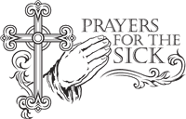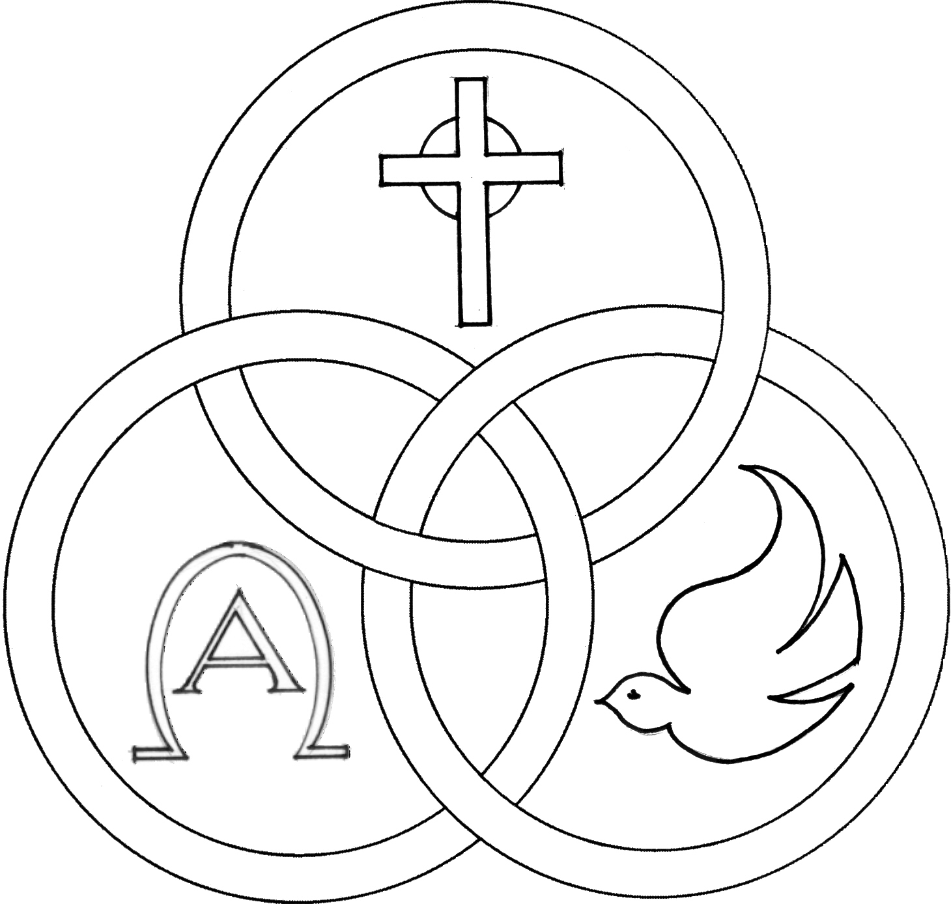**Parish of the Holy Trinity** *Roman Catholic Church*

951Stafford Road

Fall River, Massachusetts

[**www.holytrinityfallriver.com**](http://www.holytrinityfallriver.com)

***Twenty-Eighth Sunday in Ordinary Time***

**Saturday 10/11 28th Sunday in Ordinary Time**

4:00 pm Raymond & Louise Walkden *(by Lois)*

**Sunday 10/12 28th Sunday in Ordinary Time**

8:30 am Lorraine & Raymond Francoeur

*(by Family)*

10:30 am Pearl LePage *(by Sylvia)*

**Monday 10/13 Weekday**

8:30 am Ludgero Tavares, Gabriel & Rosa Patricio *(by Family)*

**Tuesday** **10/14 Weekday**

8:30 am Dowel & Charlene Spencer

*(by Vicky & Michael)*

**Wednesday 10/15 Teresa of Jesus** virgin & Doctor

8:30 am Antone & Emily Pacheco *(by Jan & Mike)*

**Thursday 10/16 Weekday**

8:30 am For the People *of our parish*

**Saturday 10/18 29th Sunday in Ordinary Time**

4:00 pm Tyler Soares

**Sunday 10/19 29th Sunday in Ordinary Time**

8:30 amJohn Lynn Sr. 6th Anniversary *(by Family)*

10:30 am Ronald Sevigny 2nd Anniversary*(by Wife)*

ISCBC005 **Blessed Sacrament Sanctuary Lamp:**

*Given this week in memory of*

Fr. John Perry

**CSOFT003 Week of 10/5/25**

**Budget $3,960.25**

**Boiler $2,158.00**

**Yellow registration forms** are available on the tablesinside Church, near each of the entrances. Please drop them into the collection basket at Mass and **introduce yourself to Father Oliveira** after Mass or call the parish office for an appointment. **We** **hope that you feel very much at home!**

**PRAY FOR THE SICK OF OUR PARISH** and our families especially for those in hospitals, rehabilitation centers, nursing facilities and the homebound. Pray for all those who are undergoing medical treatments at this time.

**THE SECOND COLLECTION** this weekend is the monthly collection for maintenance and expense reduction for our parish. Thank you for all your generosity.

**THE ANNUAL RESPECT LIFE MONTH** Mass with Bishop da Cunha, sponsored by the Knights of Columbus and hosted by the Secretariat of the New Evangelization Diocesan Family and Respect Life Office, will be celebrated on Sunday, October 12, 2025, at 10:30 a.m. at St. Mary’s Cathedral.

**ANNUAL PROCESSION AND MASS FOR PEACE** Please join Bishop da Cunha in the annual Procession and Mass for Peace on Monday, October 13, 2025. Participants are asked to gather at 5:30pm in the area of Saint Anne’s Shrine, across from Kennedy Park, to march approximately one-half mile to St. Mary’s Cathedral. The procession will begin at 6:00pm. Marchers will carry candles, recite the rosary and sing Marian hymns. Mass will be celebrated at 7:00pm.

**OUR PARISH OFFICE WILL BE CLOSED** this Monday, October 13th in observance of the Indigenous People Day (Columbus Day) holiday. Our parish office will reopen again on Tuesday, October 14th.

**FR.** **BOB’S REFLECTIONS** can still be found on facebook at Holy Trinity Parish Fall River MA or our website at holytrinityparishfallriver.com daily beginning at 7:35am.

**THE RELIGIOUS EDUCATION OFFICE**. **There will be no in house classes this Sunday, October 12th due to the Indigenous** **People Day** **(Columbus Day) Holiday Weekend.** Classes will resume next Sunday, October 19th.

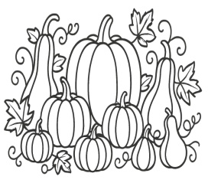**HOLY TRINITY SCHOOL CRAFT FAIR** will be on Saturday, November 1, 2025 from 10:00 am – 3:00 pm in the Church Hall. We will have local crafters, delicious food, raffles and malasadas. Admission is FREE! We hope to see you there.

**THE FAUSTINA CENTER:**

Thank you for all your gifts and help for the baby shower given to the Faustina center.

**OCTOBER IS MENTAL HEALTH AWARENESS MONTH**. In recognition of the impact that mental health challenges can have on individuals, their families and caregivers, Bishop Edgar da Cunha will offer a special Mass for World Mental Health Day on Sunday, October 19th 2025, at 10:30 a.m. at the Cathedral of St. Mary of the Assumption on Second Street in Fall River.

**THE HOLY TRINITY WOMEN'S GUILD "TAKE A CHANCE AUCTION & FOOD FEST" Holy Trinity Women’s Guild will once again sponsor an auction on Saturday, November 8th and Sunday, November** **9th** in the Church Hall. Tickets and Treats for sale on Saturday between 3:00pm & 6:00pm. On Sunday Tickets for sale 9:15am to 1:00pm. Food for sale “Eat In or Take Out” 11:30am to 1:00pm. Drawings to be held on Sunday, November 10th at 1:00pm. Winners need not be present to win. Please come and support your parish.

**HOLY TRINITY PARISH SOUP KITCHEN** will be held this Thursday, October 16th in our Church Hall. We welcome everyone to come and share a meal with us. Doors open at 5:00pm and close at 6:00pm. **Please share the word that all are most welcome to come.**

**THIS WEEK’S REFLECTION:**. All week long, the readings offer us so much about authenticity. Jesus invites us to simplicity. He wants to take us beyond obedience to the law or acts of piety. These are not bad in themselves, but they can hold a particular vulnerability to in-authenticity or hypocrisy, unless they are rooted in deep reliance upon God and faith in Jesus as our Savior. Mere cleanliness on the outside or placing burdens on people’s shoulders leaves us still far away from an experience of God’s love that overflows into love and mercy for others. This week, let’s wake up each day and ask God for the grace to be more authentic. While putting on our slippers, standing next to the bed for just 30 seconds, let’s give this special focus to our day. While washing up or getting dressed, on the way to work, while doing laundry or walking down the hall to a meeting, saying a brief grace before even a quick meal, we can remind ourselves of this desire in our hearts. Choosing humility is simply choosing honesty in very small ways. Throughout our days, each of us can find words to express to God our desire to be more honest and transparent with ourselves and with others. “Lord, let me be just who I am today. I know that in your eyes I’m a loved sinner. In grateful humility, don’t let me be harsh or judgmental with my family, with friends or co-workers. Let me give up bragging, shading the truth, any kind of falsehood. I want to abstain today from even thoughts that take me down a road of cheating on my relationships, my commitments and my relationship with you.” This is all about focus and choosing to place our attention on our relationship with Jesus in the most ordinary moments of our day. As we end each day, we can give thanks that our desire was given to us - that whenever we open our hearts, our God is always there, ready to bless our desires.

