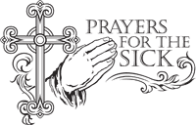
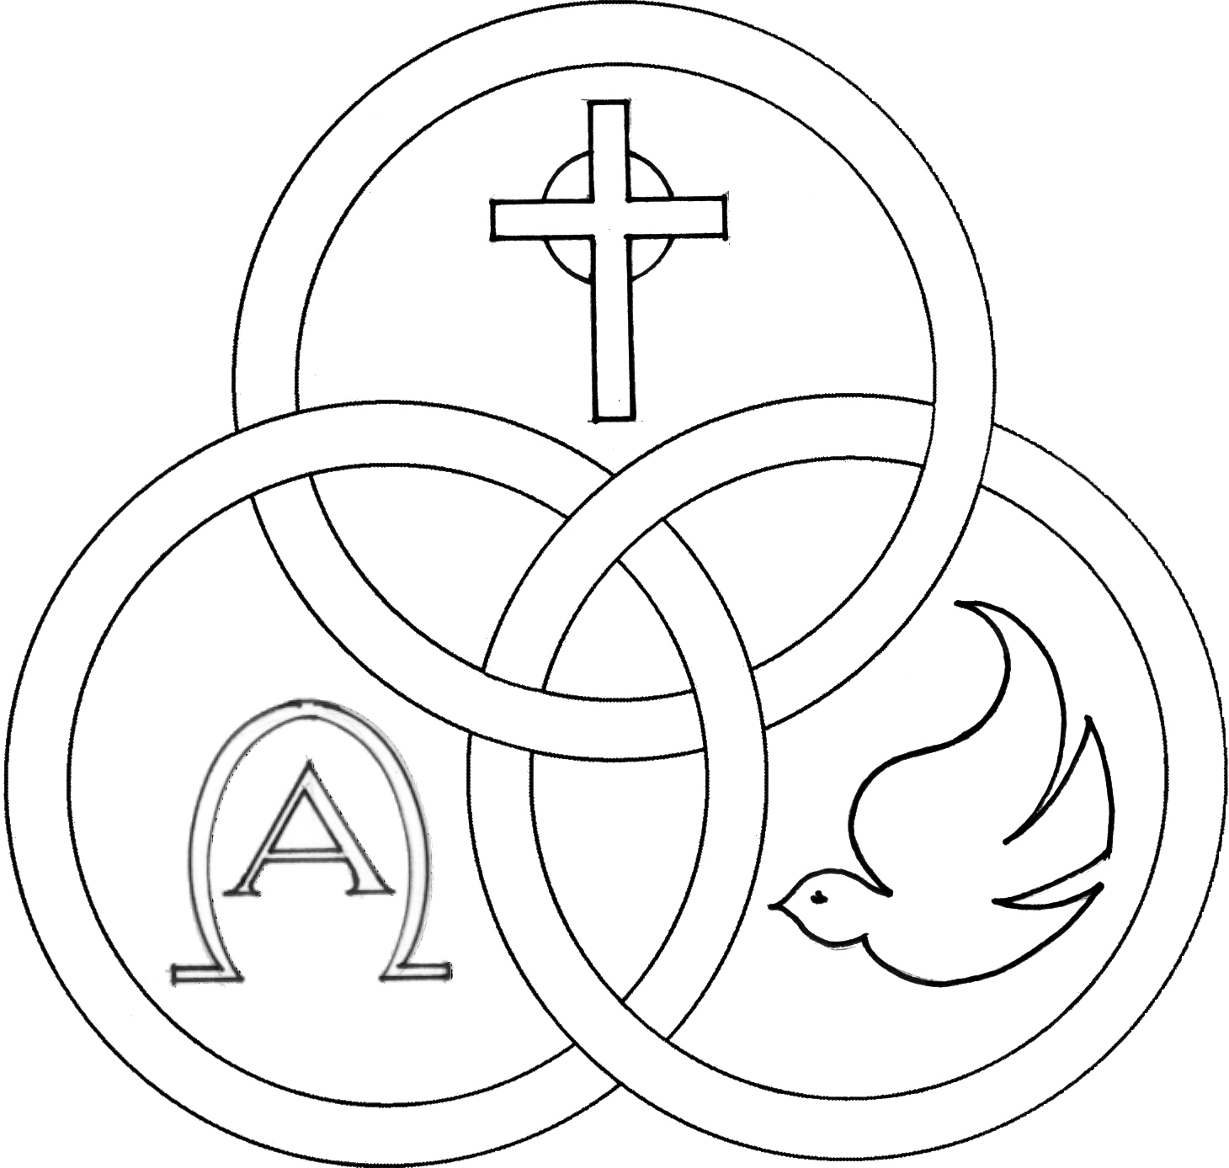
Parish of the Holy Trinity Roman Catholic Church
951Stafford Road
Fall River, Massachusetts
www.holytrinityfallriver.com

Third Sunday in Ordinary Time

Saturday 1/24 3rd Sunday in Ordinary Time
4:00 pm Teddy Karcz (by Wife & Family)
Sunday 1/25 3rd Sunday in Ordinary Time
8:30 am Robert Benevides 2nd Anniversary
(by Family)
10:30 am Fr. Dave Andrade (by Family)

Monday 1/26 Timothy & Titus, bishops
8:30 am For all those who have died. We pray in a special way for Lucille Levesque, Richard McAndrew, Brunette Beaudoin, Patricia Gamage and Rose Diniz.
Tuesday 1/27 Weekday
8:30 am Gilbert Mello (by Delores)
Wednesday 1/28 Thomas Aquinas, Priest and Doctor
8:30 am Linda Augustine
Thursday 1/29 Weekday
8:30 am For the People of our parish

Saturday 1/31 4th Sunday in Ordinary Time
4:00 pm Barbara & Bill O’Neil & Karen Costa
(by Bill)
Sunday 2/1 4th Sunday in Ordinary Time
8:30 am Henry Furtado (by Family)
10:30 am Maria de Jesus & Antonio Gervasio
(by Daughters)

Blessed Sacrament Sanctuary Lamp:
Given this week in memory of


Rev. David M. Andrade

Week of 1/18/26

Budget $3,308.00

Fuel $1,764.45
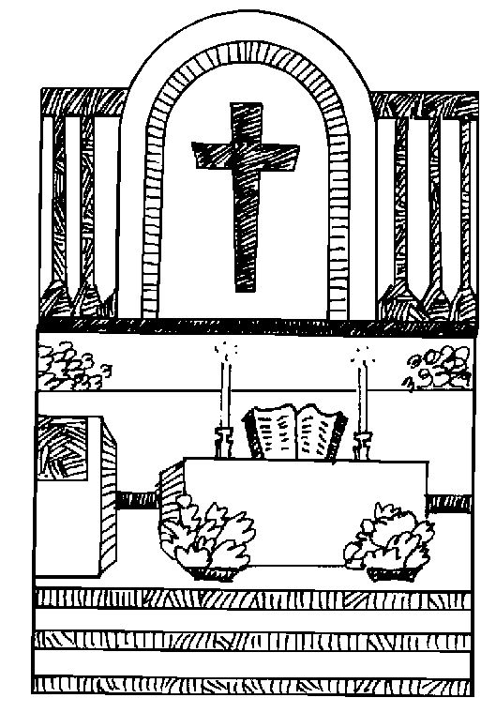


Yellow registration forms are available on the tables inside Church, near each of the entrances. Please drop them into the collection basket at Mass and introduce yourself to Father Oliveira after Mass or call the parish office for an appointment. We hope that you feel very much at home!
PRAY FOR THE SICK OF OUR PARISH and our families especially for those in hospitals, rehabilitation centers, nursing facilities and the homebound. Pray for all those who are undergoing medical treatments at this time.

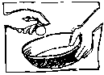
THE SECOND COLLECTION
taken up this weekend is for support of Catholic Schools. This will help us to provide much needed support for our parish school. Part of the responsibility of having a parish school is providing support and assistance for the beautiful gift it is to our parish and community. We have so much to be proud of. Thank you for your continued prayers and support!


PLEASE NOTE this weekend is also the annual national collection for the Church in Latin America. Thank you for remembering our brothers and sisters from Latin America.

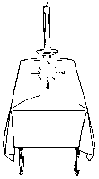
PLEASE REMEMBER IN YOUR PRAYERS Patricia Gamage and Rose Diniz whose funerals were celebrated in our parish. We extend our prayerful support to their families and friends. May their souls and the souls of all the faithful departed, through the Mercy of God rest in peace. Amen.

SHOWER FOR THE HOMELESS: In collaboration with the Catholic Social Services of the Fall River Diocese and the Holy Trinity Women's Guild we are collecting NEW ITEMS ONLY; Men, Women and Children; socks, hats, gloves, mittens, scarves, and toiletries. Please place items in the baskets at the entrances of the church. Thank you.

MASSES OF REMEMBRANCE All are welcome to this Mass that will be celebrated on Sunday, January 25, 2026, at 10:00 a.m., at St. John Neumann Church in East Freetown and on Saturday, January 31, 2026, at 9:00 a.m. in the Mausoleum Chapel at Notre Dame Cemetery in Fall River.


RELIGIOUS EDUCATION.
Classes will resume this Sunday, January 25th.


THE SACRAMENT OF CONFIRMATION will be celebrated on Tuesday, March 3, 2026 at 6:30 pm here at Holy Trinity by Bishop Edgar da Cunha. Please keep in your prayers all those who are preparing to receive the sacrament of Confirmation.


CATHOLIC SCHOOL WEEK this year is the week of January 25th. Please keep our school, teachers, staff and students in your thoughts and prayers. A SCHOOL MASS will be celebrated on Monday, January 26th at 9:30am.


OFFICE OF SAFE ENVIRONMENT All members of the clergy, Directors of Religious Education and teachers in our schools are Mandated Reporters in Massachusetts and required by law to report any suspected child abuse. Many children will not tell anyone they are being abused. Because the Diocese believes in our moral obligation to protect children, we extend the safe environment training to all who minister, work or volunteer. Watch for signs of abuse and, if you are concerned about a child, share those concerns with a mandated reporter at your parish or school. Let us all be a voice for children who may not be able to speak for themselves.


THIS WEEK’S REFLECTION: This is a week where Jesus speaks of seeds being planted and of growing. We are still at the beginning of a new year, and this is a good time to answer the call in our hearts to spend more time with Jesus, in prayer. “I’m not very good at prayer,” we might say. “I don’t have the time to pray.” Jesus is not waiting for us to be perfect before we talk to him - he is simply waiting, right now, for us to come to him in our own humanity. This week we are invited to uncover the light of our faith, the light that warms the longing we feel in our souls for something different or deeper in our relationship with God. At this beginning of the year, we might step back and examine the ways we talk with Jesus - and the ways we hold him at arm’s length. We are being called into a relationship, a friendship, with someone who delights in us and waits for us to release our fears and come out of hiding. Where do we start? With the desire. It can be so simple to take the empty moments of our day and just tell the same Jesus who healed and loved on earth, what is in our hearts. In the early morning moments before we get out of bed, while in the shower or traveling to work, cooking or walking the dog - we can stop and open our hearts. “Jesus, you know what is in my heart. You know what my needs are. Help me to be more open to the way you are calling me in my life.” Our prayer can be as simple as opening our hands on our lap for a moment and saying in our own words, “Show me how to come out of hiding. Give me the courage to let go of my fears and bring myself to you in honesty. Let me drop the many defenses I carry that keep me from feeling how deeply you love and accept me.” There is no right or wrong way to approach Jesus - the only right thing is that we come with an open heart and our own desire for something deeper. Every evening as we end our day, we can sit at the edge of our bed with our hands open and say, “Thank you.” We can reflect on the many ways we felt the love of God in our lives that day. What tiny seed was planted in my life to bloom? Where did I shine the light of my own faith on someone?


FR. BOB’S REFLECTIONS can still be found on facebook at Holy Trinity Parish Fall River MA or our website at holytrinityparishfallriver.com daily beginning at 7:35am.

