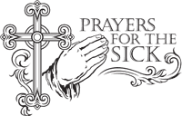
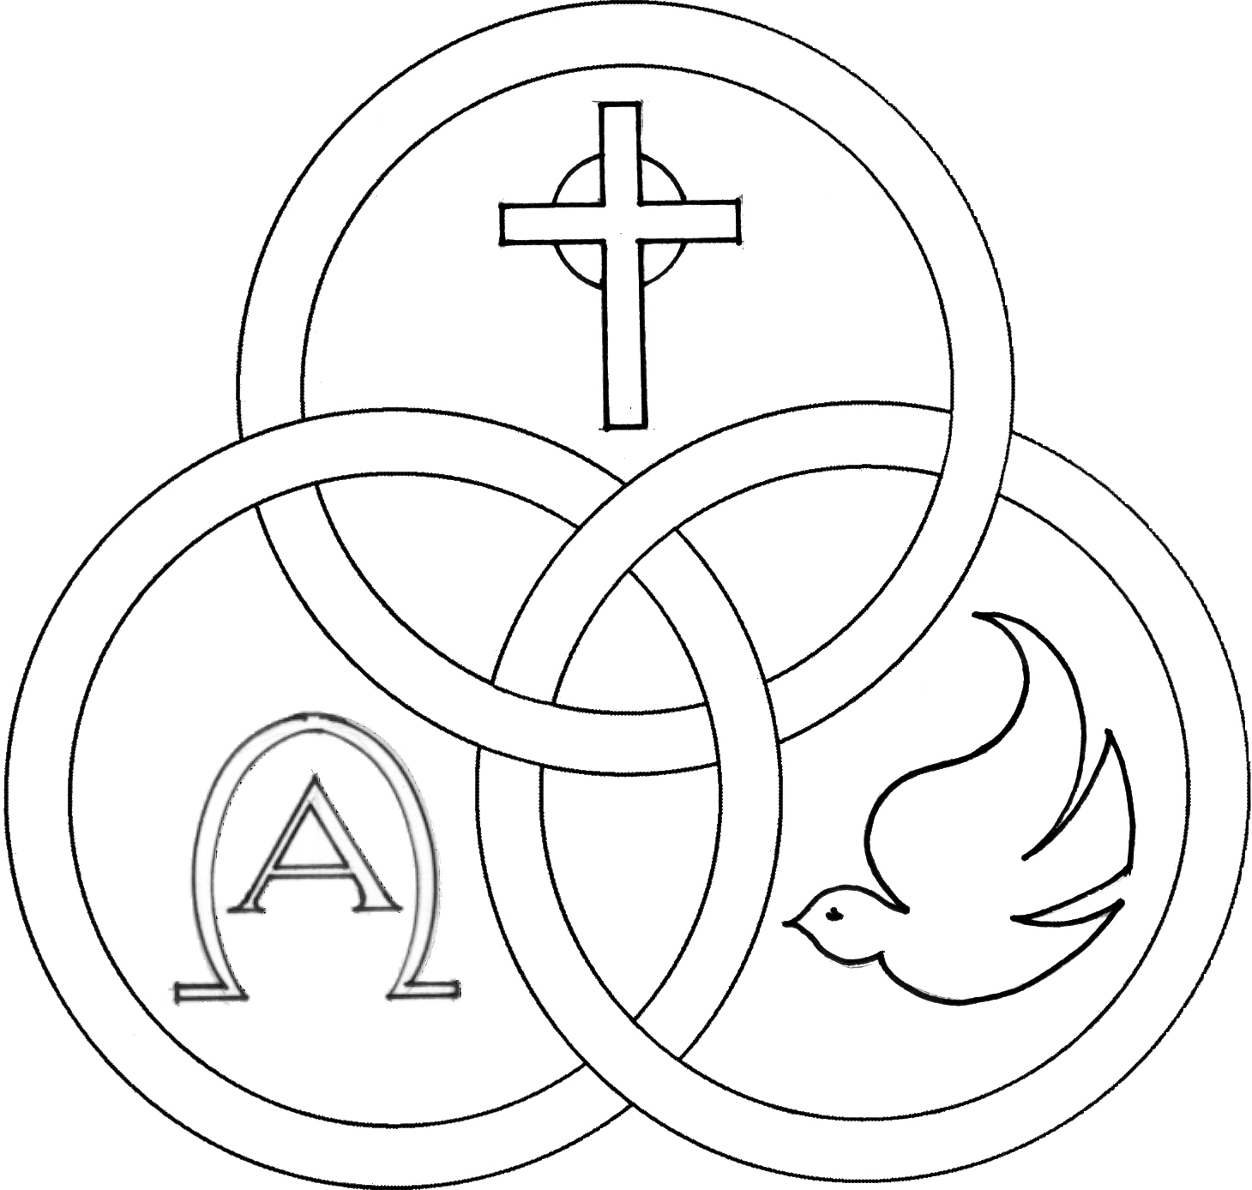
Parish of the Holy Trinity Roman Catholic Church
951Stafford Road
Fall River, Massachusetts
www.holytrinityfallriver.com

Third Sunday of Advent

Saturday 12/13 3rd Sunday of Advent
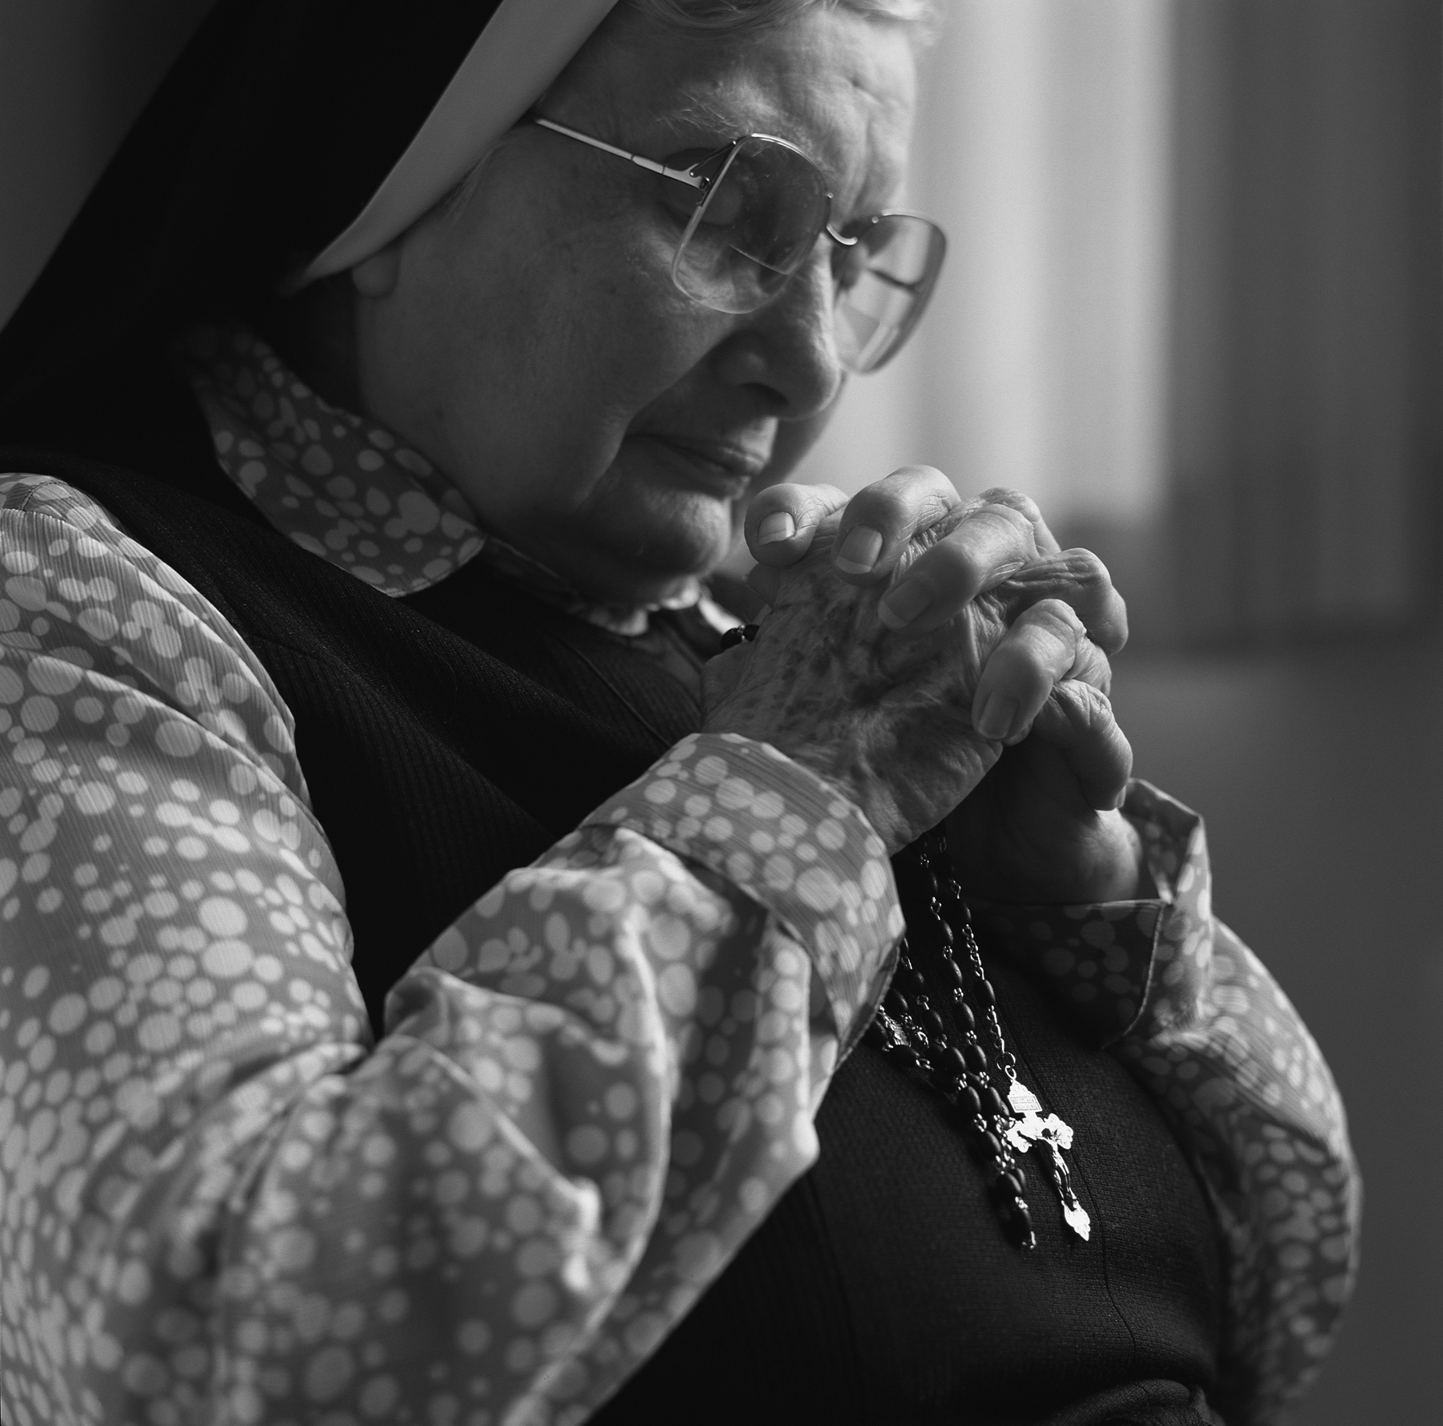
4:00 pm Andre Bernier (by Family)
Sunday 12/14 3rd Sunday of Advent
8:30 am John Lynn Jr. 19th Anniversary (by Family)
10:30 am Augusta Andrade & Manuel Felix

Monday 12/15 Advent Weekday
8:30 am Jamie & Marie DaPonte
Tuesday 12/16 Advent Weekday
8:30 am John & Maria Fernandes & Silvester & Isabel Pavao (by Family)
Wednesday 12/17 Advent Weekday
8:30 am Edward Medeiros
Thursday 12/18 Advent Weekday
8:30 am For the People of our parish

Saturday 12/20 4th Sunday of Advent
4:00 pm Jose & Mariana Velho
Sunday 12/21 4th Sunday of Advent
8:30 am Lorraine J. Dion (by Husband & Daughters)
10:30 am Mary Botelho & Fr. David Andrade

Blessed Sacrament Sanctuary Lamp:
Given this week in memory of

Barbara & Manuel Mendonca

By Family

Week of 12/7/25

Budget $4,369.00

Snow Removal $2,149.00


Yellow registration forms are available on the tables inside Church, near each of the entrances. Please drop them into the collection basket at Mass and introduce yourself to Father Oliveira after Mass or call the parish office for an appointment. We hope that you feel very much at home!
PRAY FOR THE SICK OF OUR PARISH and our families especially for those in hospitals, rehabilitation centers, nursing facilities and the homebound. Pray for all those who are undergoing medical treatments at this time.

THE SECOND COLLECTION taken up this weekend is the annual national collection for Retired Religious. Religious communities have served the Church in so many ways over the years. Many of us remember them fondly as they taught in our Catholic Schools, as well as, their work in many other ministries and apostolates. Often in the past they only received a mere stipend for their years of dedicated service and now in their retirement they face tremendous bills for health care and support. Thank you for your support of our retired religious sisters and brothers.


PLEASE REMEMBER IN YOUR PRAYERS Humberto Campos and Maria Cabral whose funerals were celebrated in our parish. We extend our prayerful support to their families and friends. May their souls and the souls of all the faithful departed, through the Mercy of God rest in peace. Amen.

CHRISTMAS FLOWER MEMORIAL A memorial bulletin will be published at Christmas listing the names of our loved ones. The envelope found in our special mailing contains a space to indicate the name(s) of those you wish to remember. Please return your Christmas Flower envelope by Monday, December 15th to ensure a listing in our memorial bulletin. Thank you for helping us to decorate our beautiful Church for Christmas!


FR. BOB’S REFLECTIONS can still be found on facebook at Holy Trinity Parish Fall River MA or our website at holytrinityparishfallriver.com daily beginning at 7:35am.

THE RELIGIOUS EDUCATION OFFICE. Please note, there are no class this week for the First Communion and Confirmation Class. All other classes grades 3 thru 7 will be provided materials online by accessing the FACEBOOK SITE of Holy Trinity Parish Fall River MA.

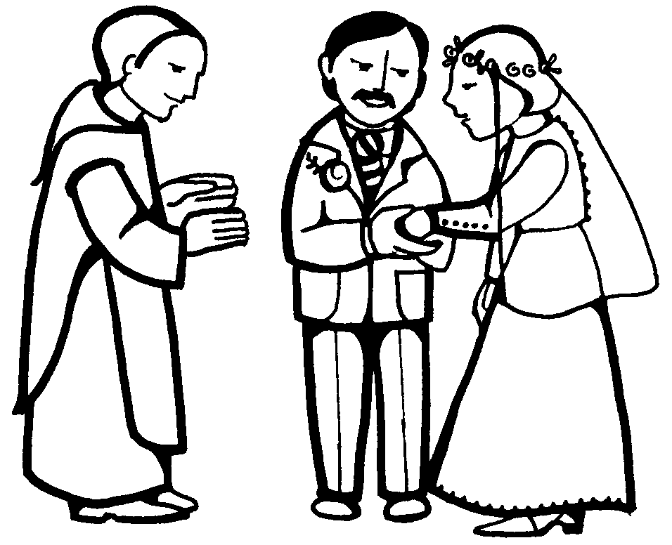
WEDDING ANNIVERSARY CELEBRATION: The Annual Diocesan Wedding Anniversary Celebration will be celebrated with a special Mass of Thanksgiving for couples observing significant wedding anniversaries (including first year). Renew your wedding vows with the Bishop of Fall River on Sunday, February 8, 2026, at 3:00 p.m. at St. Mary Cathedral in Fall River. If you would like an invitation, please call the parish office as soon as possible. The registration deadline for this event is January 16, 2026.

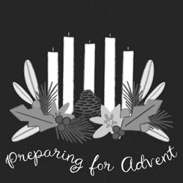
ADVENT REFLECTIONS: “Mystery of Hope.” Join Fr. Bob online with a weekly Advent Reflection. You can find this on facebook at Holy Trinity Parish Fall River MA or our website at holytrinityparishfallriver.com

SOLEMNITY OF CHRISTMAS
Schedule of Masses

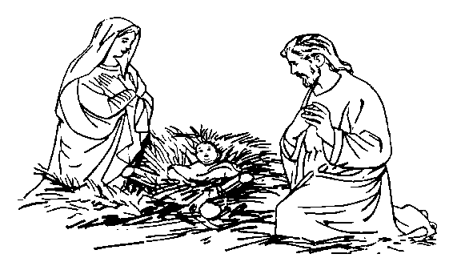

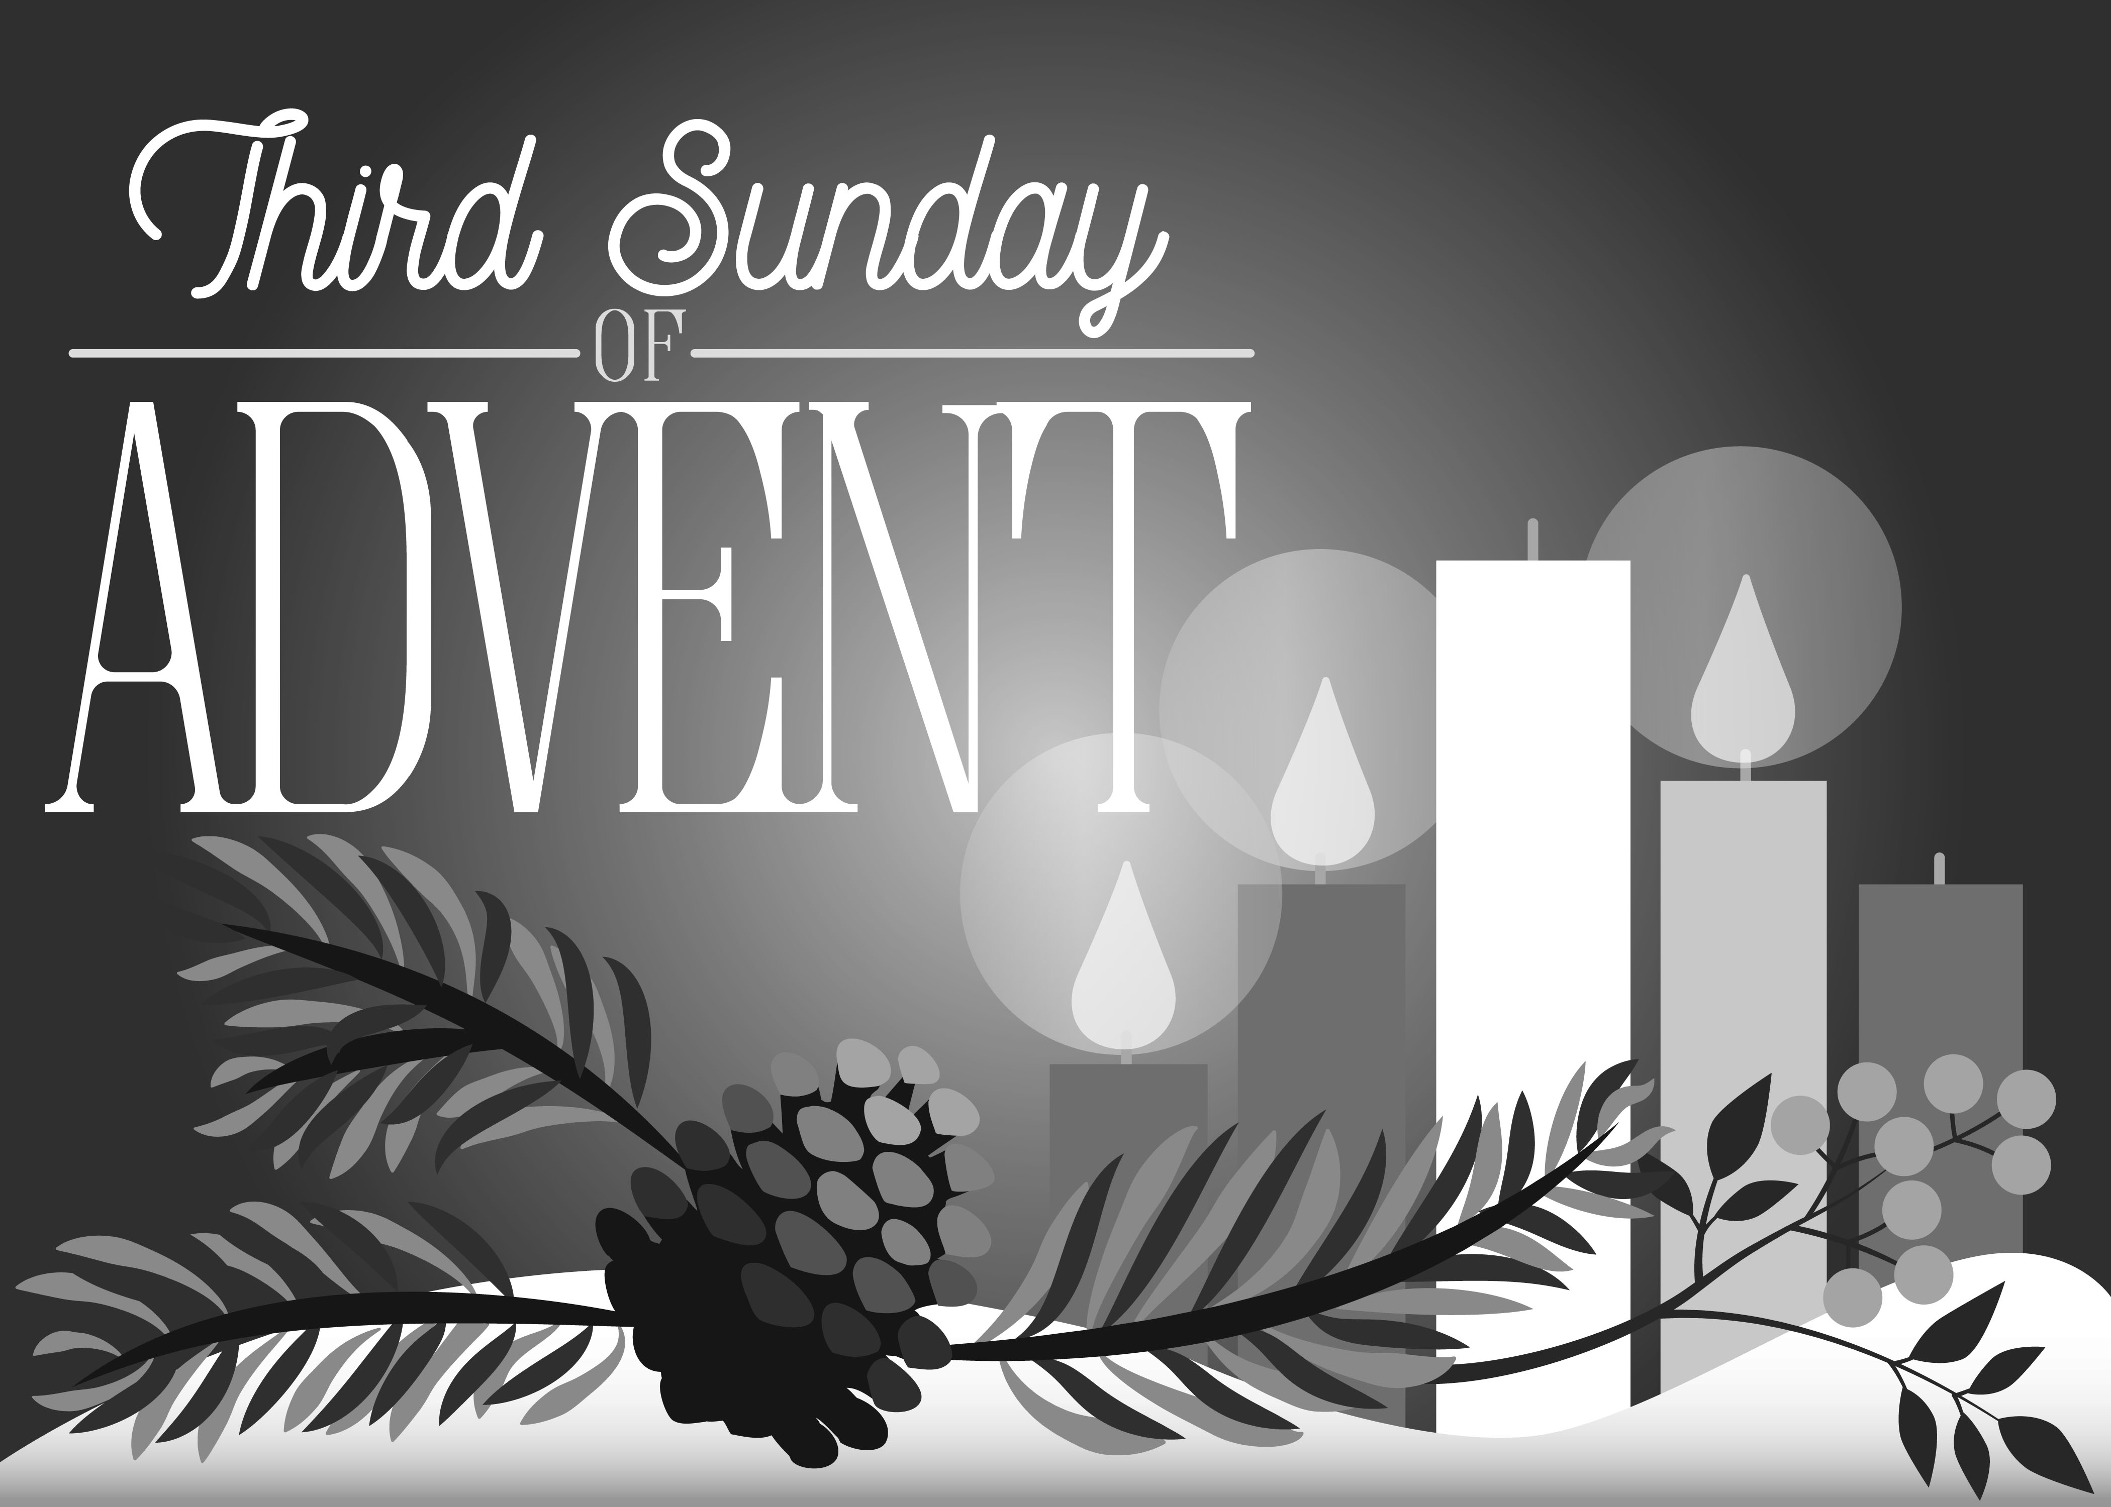
Christmas Eve
Wednesday, December 24th
Vigil Mass - 4:00pm

Christmas Day
Thursday, December 25th
Mass of the Day - 8:30am & 10:30am

THIS WEEK’S REFLECTION: This third week of Advent, our daily prayer continues to allow us to become much more concrete about naming our desires and preparing the way for the Lord. We begin this week with joy, knowing that our celebration of all the ways our Lord comes to us is near. For some of us, the great grace will be to ask that expectant hope - and the joy that this can bring - will fill our hearts and replace whatever is heavy or dark or sad there. We can only let our Lord bring good news to us who are poor, if we acknowledge our poverty. He can only proclaim liberty and release to us if we can admit that we are captives and prisoners to so many habits and patterns that inhibit joy. A week of recognizing ourselves, and recognizing our need for a Savior is a wonderful way to prepare. We can only turn to our God and trust in the safety we find accepting our God as the only god of our lives if we first can name the place in which we are in danger, with the choices we are making. We can surrender our fear of being put to shame by humbly coming face to face with who we can sometimes be. The depths of gratitude and joy come when we can experience the tenderness with which our Lord keeps taking us back. This is a wonderful week to examine our consciences as we let our daily, prayer-filled background moments interact with some of the places in our daily lives in which we discover the need for mercy and peace. Wherever we encounter some experience of darkness or fear, some struggle with faith or hope, some discouragement about my own generosity or freedom, it is there that we have an opportunity to pause, in the briefest way and pray, “Come, Lord Jesus; come and visit me here, in this place.” Preparing to celebrate the Sacrament of Reconciliation, individually or in common, can be a powerful Advent religious experience. And the one who forgives us deeply desires to heal us and give us his peace.

