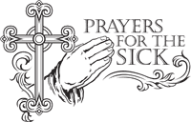
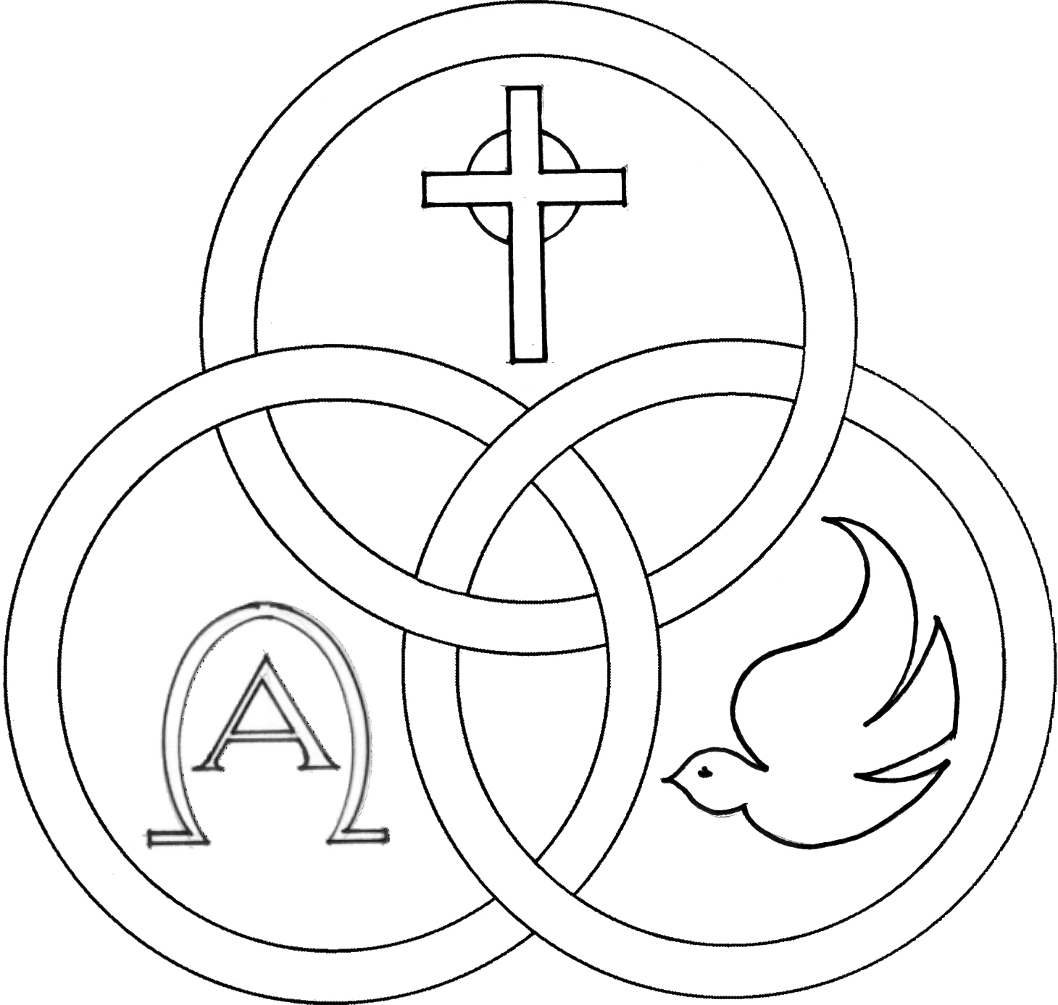
Parish of the Holy Trinity Roman Catholic Church
951Stafford Road
Fall River, Massachusetts
www.holytrinityfallriver.com

Fifth Sunday in Ordinary Time

Saturday 2/7 5th Sunday in Ordinary Time

4:00 pm Michael J. Tremblay (by Wife & Family)
Sunday 2/8 5th Sunday in Ordinary Time
8:30 am Francisco DeAndrade (by Wife)
10:30 am Mary Botelho (by Family)

Monday 2/9 Weekday

8:30 am M/M Antone Oliveira (by Family)
(by sister Cindy) .
Tuesday 2/10 Scholastica, virgin
8:30 am John Ponte (by Sister)
Wednesday 2/11 Weekday
8:30 am Raymond Mello & Mello Family
Thursday 2/12 Weekday
8:30 am For the People of our parish

Saturday 2/14 6th Sunday in Ordinary Time
4:00 pm Ludgero Tavares (by Wife)
Sunday 2/15 6th Sunday in Ordinary Time
8:30 am Maria Camara & Emily Silva (by Family)
10:30 am Yvonne Boisvert Manchester (by Family)

Blessed Sacrament Sanctuary Lamp:
Given this week in memory of

Michael J. Tremblay

By Wife & Family


Week of 2/1/26

Budget $3,857.72

Maintenance $2,100.41



Yellow registration forms are available on the tables inside Church, near each of the entrances. Please drop them into the collection basket at Mass and introduce yourself to Father Oliveira after Mass or call the parish office for an appointment. We hope that you feel very much at home!
PRAY FOR THE SICK OF OUR PARISH and our families especially for those in hospitals, rehabilitation centers, nursing facilities and the homebound. Pray for all those who are undergoing medical treatments at this time.

THE SECOND COLLECTION this weekend is the annual national collection for the Catholic University of America. Thank you for all your support!

PLEASE REMEMBER IN YOUR PRAYERS Seraphim Machado whose funeral was celebrated in our parish. We extend our prayerful support to his family and friends. May his soul and the souls of all the faithful departed, through the Mercy of God rest in peace. Amen.

EXCITING NEWS FROM THE ANCHOR: The Anchor, the long standing newspaper of Diocese of Fall River, is transitioning from a paid monthly print edition to a free weekly electronic newsletter. Signing up is simple. Visit www.bit.ly//Anchornewsletter or the diocesan website, fallriverdiocese.org, and provide your name and e-mail address. Stay informed and stay connected with all the news and events in Diocese plus the latest developments in the Catholic Church across the country and around the world. Look for the first Anchor newsletter in mid February along with a new and enhanced Anchor website.

HOLY TRINITY YOUTH CHOIR: This Sunday, February 8th the Holy Trinity Youth Choir will be singing at the 10:30 am Mass.

FR. BOB’S REFLECTIONS can still be found on facebook at Holy Trinity Parish Fall River MA or our website at holytrinityparishfallriver.com daily beginning at 7:35am.


RELIGIOUS EDUCATION: There will be no classes NEXT Sunday, February 15th due to Presidents Day Holiday. Classes will resume on Sunday, February 22nd.


THE SACRAMENT OF CONFIRMATION will be celebrated on Tuesday, March 3, 2026 at 6:30 pm here at Holy Trinity by Bishop Edgar da Cunha. Please keep in your prayers all those who are preparing to receive the sacrament of Confirmation.

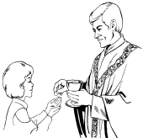
THE SACRAMENT OF THE FIRST EUCHARIST will be celebrated here in our parish on Sunday, May 3rd. Please keep in your prayers the children who will be making their First Communion.

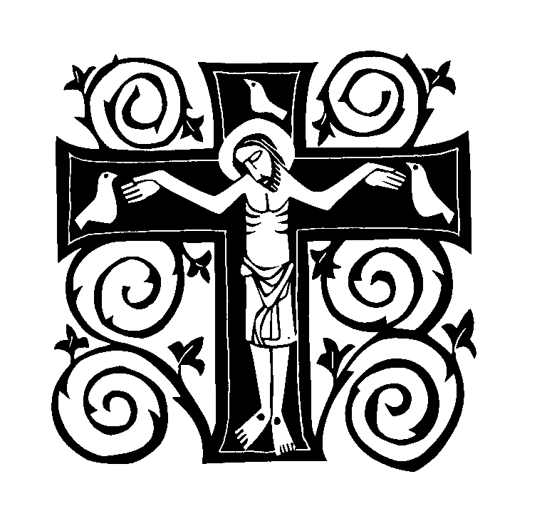
2026 FALL RIVER DEANERY LENTEN MISSION “Into the Desert: Our Lenten Journey” is scheduled for Monday, February 23rd thru Thursday, February 26th and will be offered by Mother Marla of the Maronite Servants of Christ the Light and Fr. Claude Franklin.
Quench your thirst with wisdom from the Desert Fathers’ insights on asceticism, prayer, humility, temptation, hospitality, perseverance, silence, poverty and detachment.

Daytime Sessions at St. Mary’s Cathedral
327 Second St. Fall River, MA 02721

Confessions: 11:15am-11:45am
Mass and Mission Talk: 12:00pm

Evening Sessions at Bishop Connolly High School 373 Elsbree St. Fall River, MA 02720

Confessions: 6:00pm-6:45pm
Mass and Mission Talk: 7:00pm

All are most welcome!

THIS WEEK’S REFLECTION: “My heart is moved with pity,” Jesus says in one of the gospels this week, and we see his compassion in the healing stories in this week’s gospels. This seems like the perfect time for us to ask Jesus for the healing we need in our lives. We can take one gospel and pray with it as if we were in the story - like Monday’s story. Jesus and his disciples cross the sea and as soon as they land, people rush to bring those who need healing to him. We can imagine ourselves seeing Jesus, the crowds gathering, the jostle of people bringing their sick on mats. People yelling for Jesus’ attention. Then we can imagine a moment where Jesus steps away from the throng and takes us aside. With loving eyes he looks at us and asks us, “Where do you need healing? Where can I be with you?” It is there in that powerful moment that we can speak to Jesus as we would a friend. We can search our hearts and ask Jesus for the healing he already knows we need: “Help me, Jesus, with my impatience with my family. Let me not nag at those I love so much. Heal my lack of compassion for them.” “Touch my heart, Jesus. Give me the selfless love I need in my marriage and help me avoid the temptation to ‘keep score.’ Only with your help can I continue to be loving, even when it feels like some days I am the only one carrying my marriage.” “Jesus, I become afraid of failing and I feel like one of those people lying on a mat, waiting for you to touch my life. Yet when I sense your healing presence coming close, I roll away from you so you don’t see me. Give me the courage I need to ask for your healing and to get up and answer your call for me to serve.” When we pray with a gospel, we can carry an image of that prayer with us all day long. As we get out of bed in the morning, cook meals or go about our day, we can be aware of Jesus standing with us, ready to heal us, if only we would ask. What is it that needs healing in me this week? Where will I allow Jesus to touch my life?



