
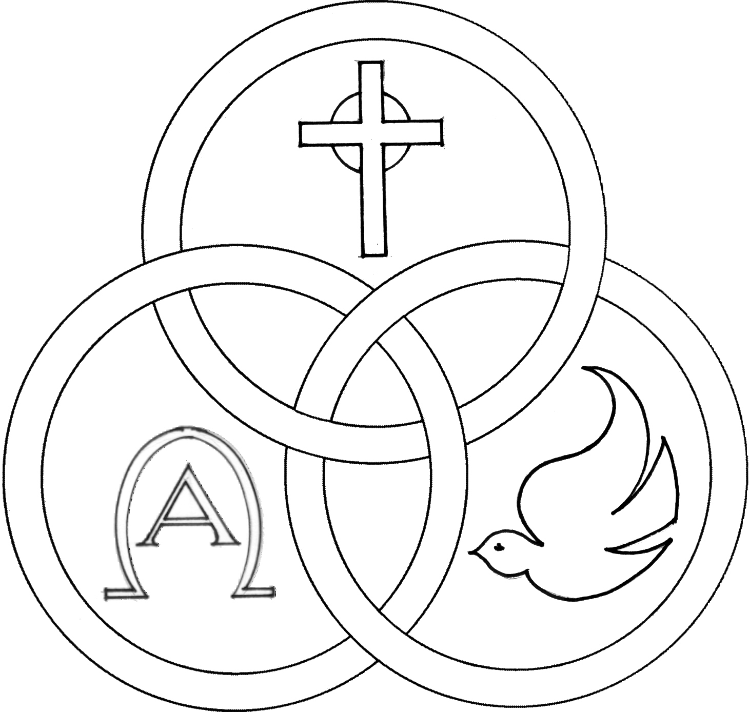
Parish of the Holy Trinity Roman Catholic Church
951Stafford Road
Fall River, Massachusetts
www.holytrinityfallriver.com

Sixth Sunday of Easter

Saturday 5/9 6th Sunday of Easter
4:00 pm John Hopkins (by Wife)
Sunday 5/10 6th Sunday of Easter
8:30 am For All Mothers Living & Deceased
10:30 am For All Mothers Living & Deceased

Monday 5/11 Easter Weekday
8:30 am Jose & Lucinda deSousa (by Fatima Vieira)
Tuesday 5/12 Easter Weekday
8:30 am Angelina & Joao Carvalho (by Family)
Wednesday 5/13 Easter Weekday
8:30 am Ludgero Tavares & Maria C. Fagundes
(by Family)
Wednesday 5/13 Ascension of the Lord
6:00pm Emily Pacheco & Laura Arruda
(by Jan & Mike)
Thursday 5/14 Ascension of the Lord
8:30 am For the People of our parish

Saturday 5/16 7th Sunday of Easter
4:00 pm Barbara & William O’Neil & Karen Costa (by Bill)
Sunday 5/17 7th Sunday of Easter
8:30 am Maria Rebello 4th Anniversary (by Family)
10:30 am Gilbert Faria Birthday Remembrance
(by Madeline & Family)

Blessed Sacrament Sanctuary Lamp:
Given this week in memory of

Lucinda & Antonia Oliveira

By Fatima

Week of 05/3/26

Budget $3,782.00
Initial Offering $1,806.00


Yellow registration forms are available on the tables inside Church, near each of the entrances. Please drop them into the collection basket at Mass and introduce yourself to Father Oliveira after Mass or call the parish office for an appointment. We hope that you feel very much at home!
PRAY FOR THE SICK OF OUR PARISH and our families especially for those in hospitals, rehabilitation centers, nursing facilities and the homebound. Pray for all those who are undergoing medical treatments at this time.


THE SECOND COLLECTION
this weekend is for the parish assessment. I thank you for your generous support.

THE FEAST OF THE LORD’S ASCENSION, a holyday of obligation, will be celebrated THIS coming Thursday, May 14th. Masses will be celebrated in our parish on Wednesday, May 13th at 6:00pm and on Thursday, May 14th at 8:30am.

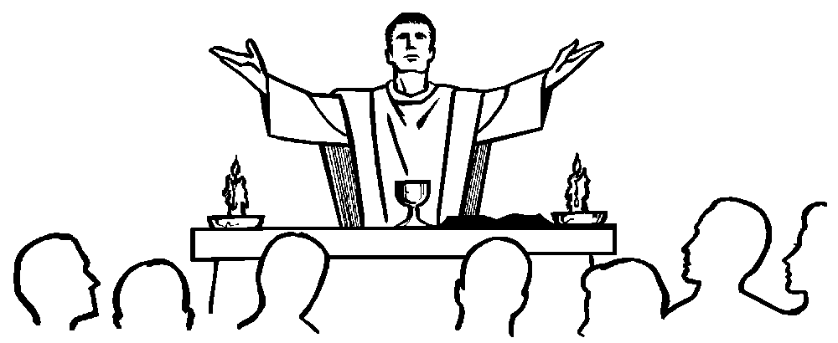

MASS INTENTIONS

The Mass Intention Book will open for July thru December 2026 on May19th. In fairness to all our parishioners only 2 weekend and 4 weekdays Masses can be scheduled at this time. After June 9th you can schedule more Masses if there are still openings. You can come to the parish office or call the office at 508-672-3200 between the hours of 10:00am and 2:00pm to book Masses and sanctuary lamp.


FR. BOB’S REFLECTIONS can still be found on facebook at Holy Trinity Parish Fall River MA or our website at holytrinityparishfallriver.com daily beginning at 7:35am.

Homemade MALASADAS

Next Sunday, May 17


THE RELIGIOUS EDUCATION OFFICE: Classes have ended for this year. We thank Fr. Bob, Michael and Vicky Robertson and Janice Heinig and all who helped our program in any way. We thank them for giving of their time and talent and dedication to help hand on and support the gift of faith.


FIRST COMMUNION: CONGRATULATIONS to
Aubriella Ahaesy, Liam Araujo, Connor Barrette, Melinda Belicio, Brooklyn Borges, Jameson Connelly, Aniyah Cordeiro, Noah Costa, Vera DaSilva, Nick Dinh, Lianna Estrella, Anthony Ferreira, Leah Folger, Vivian Galante, Danielle LaFontaine, Joseph LeBlanc, Sage Lizotte, Mila Lopez, Nathan Ma, Evelyn Massoud, Isaac Novo, Gabriella Pimentel, Landyn Pinksaw, Philip Pinto Jr., Alivia Soares, Lincoln Teixeira and Benjamin Zachary who received their first communion during a celebration this past Sunday, May 3rd at a 1:00pm Mass.

THANK YOU – THANK YOU – THANK YOU from the children to: our pastor Rev. Robert Oliveira; and our catechists, Mrs. Joann DaRosa, Mrs. Janice Heinig and aides Mrs. Lily Megna and Mrs. Michelle Soares and our principal Mrs. Brenda Gagnon.

Our thanks to our organist Mrs. Patricia Roies and the members of the Holy Trinity Youth Choir, along with the altar servers, Eucharistic Ministers, and all who helped to make this Mass special. Finally, to our families for all they do to witness God’s love every day.


THE 85th ANNUAL CATHOLIC APPEAL FOR THE FALL RIVER DIOCESE: “PEACE: Let it begin with me.”
The Catholic Appeal has a tremendous impact on our community as over tens of thousands of people are assisted annually across the Diocese of Fall River. We would ask that you prayerfully consider returning your donation along with your contribution card, either in the collection basket or by sending it to the Appeal office at your earliest convenience. With our first report to appeal headquarters our total so far is $5,336.00. Last year’s total was $38,487.00. EXTRA CATHOLIC APPEAL CONTRIBUTION CARDS AND ENVELOPES are available on the tables for anyone who may need one for this year’s Appeal. Thanks for all your help and generous assistance to those in need!
THIS WEEK’S REFLECTION: This is a great week to try to live in the promise of Jesus that we don’t need to let our hearts be troubled. We can trust. He will not leave us on our own. We can prepare for the coming feast of Pentecost by letting the Holy Spirit console us and gather us. But, what if I do have some troubles and worries? We can talk with our Lord about our desires regarding those anxieties and difficulties in the background moments of our life each day. For example, when I wake up, I can take a moment, while still at my bedside, letting myself name the struggles I will face that day, and simply asking the Lord to give me the graces I need today. That can take less than a minute, or 30 seconds, as the week goes on. In the shower, and while getting dressed, I can flesh out that desire. O Lord, you know this is just tying me up in knots. I haven’t slept well for a while and I feel so bad for snapping at my family last night. The specific grace I ask for today is to be calmed by your Spirit, and to place my trust in you. Give me the grace I need to not surrender my peace so easily. O Lord, my spouse is really so angry and tight, and it seems we are just driving our teenager farther and farther from us, in rebellion. I don’t know what to do. I’m responding to both of them badly. Today, let me focus on your love for me, so that I can be peaceful and calm in trying once more to calm the angry seas with simple love, with gentle affirmation, and patience that is a gift of your Spirit. And, throughout the day, we can find moments -walking from one place to another, reaching for the phone, opening a jar of something, walking down a shopping aisle at the store, filling the car with gas - when all of this will come back and we can renew our trust in the Lord’s promise. Especially, when we go to bed each night, we can give thanks, that we were not alone this day.



