
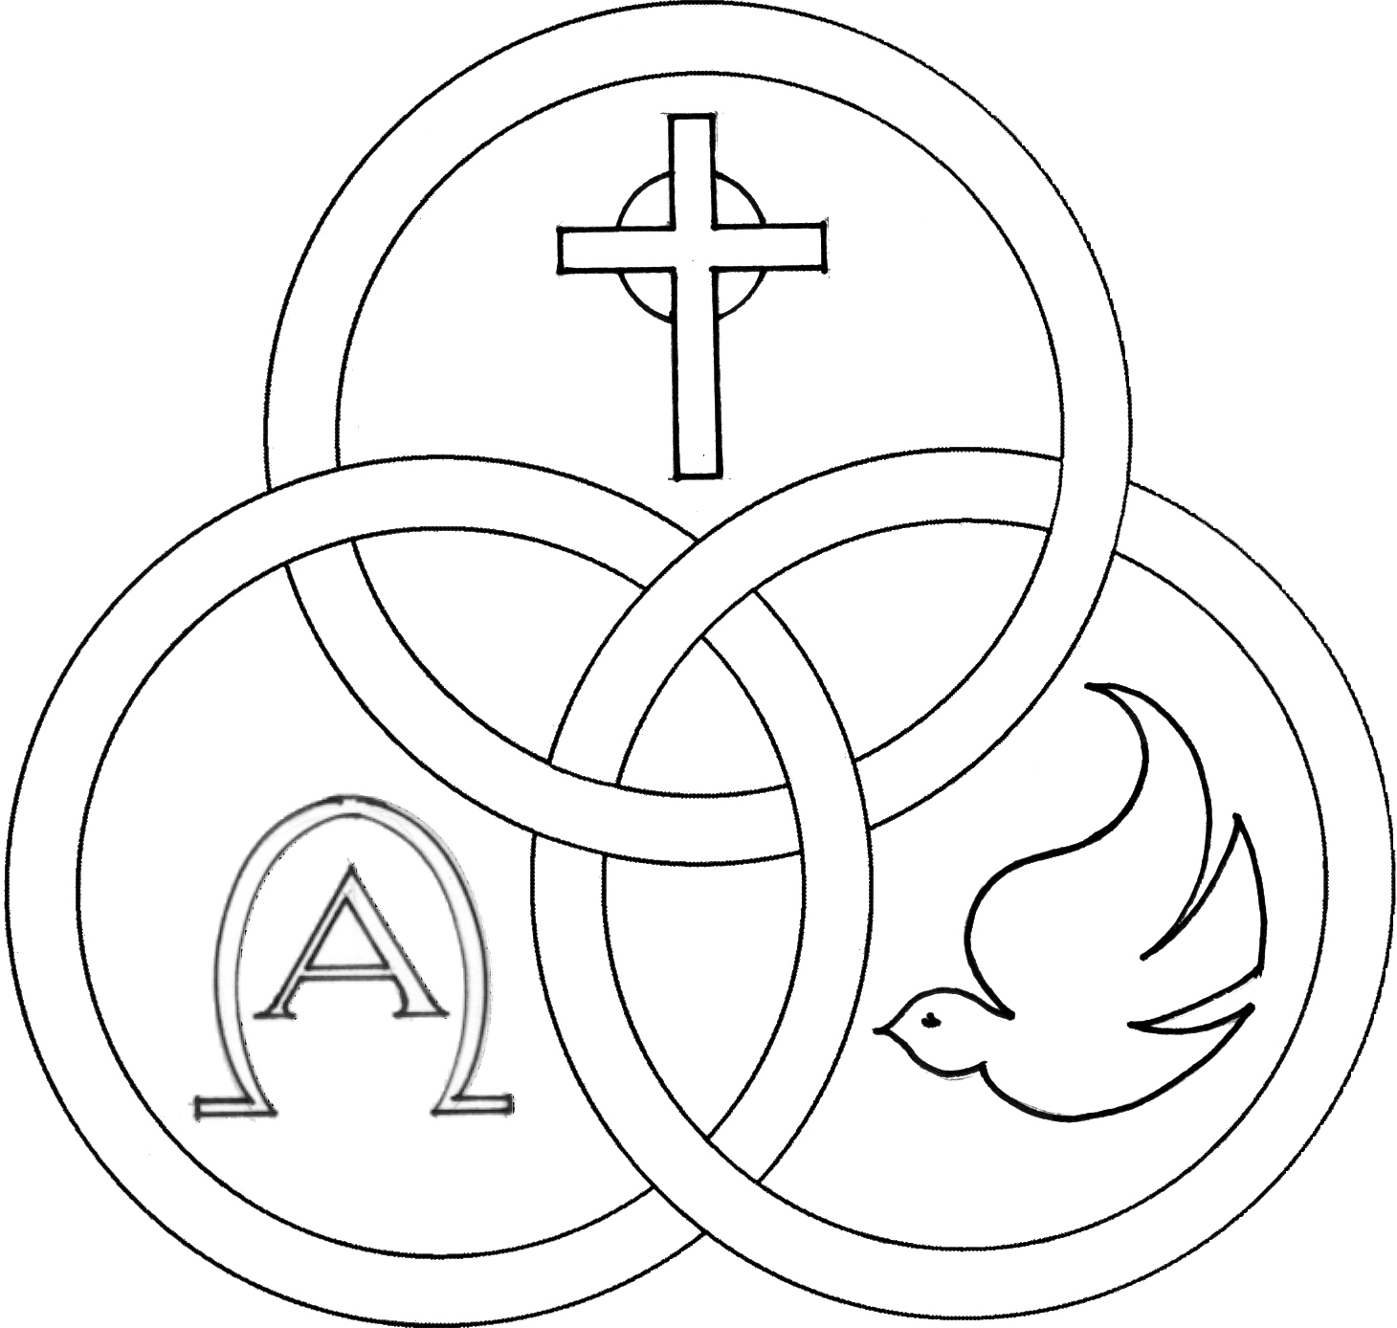
Parish of the Holy Trinity Roman Catholic Church
951Stafford Road
Fall River, Massachusetts
www.holytrinityfallriver.com

Dedication of the Lateran Basilica

Saturday 11/8 Dedication of the Lateran Basilica
4:00 pm Ludgero Tavares 12th Anniversary
(by Wife & Daughters)
Sunday 11/9 Dedication of the Lateran Basilica
8:30 am Dorothy Chaves 5th Anniversary
(by Family)
10:30 am John Albernaz & Parents (by Family)

Monday 11/10 Leo the Great, pope & doctor
8:30 am Richard Urban (by Dolores)
Tuesday 11/11 Martin of Tours, bishop
8:30 am Jamie DaPonte
Wednesday 11/12 Josaphat, bishop & martyr
8:30 am Raymond Mello & Oliveira family
Thursday 11/13 Frances Xavier Cabrini, virgin
8:30 am Lorraine J. Dion (by Husband & Daughter)

Saturday 11/15 33rd Sunday of Ordinary Time
4:00 pm Victorino Soares Jr. (by Wife & Family)
Sunday 11/16 33rd Sunday of Ordinary Time
8:30 am William & Margaret O’Neil & Family (by Bill)
10:30 am Kenneth Furtado (by Wife & Family)

Blessed Sacrament Sanctuary Lamp:
Given this week in memory of

Monsignor John Perry

Week of 11/2/25

Budget $4,722.00

Boiler $2,221.00


Yellow registration forms are available on the tables inside Church, near each of the entrances. Please drop them into the collection basket at Mass and introduce yourself to Father Oliveira after Mass or call the parish office for an appointment. We hope that you feel very much at home!
PRAY FOR THE SICK OF OUR PARISH and our families especially for those in hospitals, rehabilitation centers, nursing facilities and the homebound. Pray for all those who are undergoing medical treatments at this time.


THE SECOND COLLECTION
this weekend is to help assist our parish with the substantial fuel and heating costs that we incur during the fall and winter seasons. Thank you so very much for all your support!

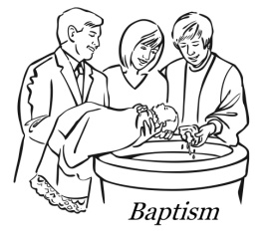
WE WELCOME Vivian Nicole Rioux and Nicholas Alexander Sousa into our parish family through the Sacrament of Baptism. We extend our congratulations and prayerful support to their parents and families. A very special welcome to the newest members of our parish family.

MONTH OF NOVEMBER PRAYER BOX ON ALTAR contains the All Souls envelopes and names submitted to the parish for prayers during the month of November. The names of our beloved deceased will be remembered throughout the month of November and the prayer box will be on the altar of sacrifice or the altar of repose (the tabernacle) throughout November. Anyone who would like to add a list of names, please give them to Father Oliveira.


THE HOLY TRINITY WOMEN'S GUILD "TAKE A CHANCE AUCTION & FOOD FEST" Holy Trinity Women’s Guild will once again sponsor an auction this Saturday, November 8th and Sunday, November 9th in the Church Hall. Tickets and Treats for sale on Saturday between 3:00pm & 6:00pm. On Sunday Tickets for sale 9:15am to 1:00pm. Food for sale “Eat In or Take Out” 11:30am to 1:00pm. Drawings to be held on Sunday, November 9th at 1:00pm. Winners need not be present to win. Please come and support your parish.


OUR PARISH OFFICE WILL BE CLOSED this Tuesday, November 11th in observance of the Veteran’s Day holiday. Our office will re-open on Wednesday, November 12th.

THE RELIGIOUS EDUCATION OFFICE. There will be no in house classes this Sunday, November 9th due to the Veteran’s Day Holiday Weekend. Classes will resume next Sunday, November 16th.


MASS ATTENDANCE The Diocese of Fall River has requested that the parishes of the diocese report weekend Mass attendance during the month of November. These numbers are important and the data will be sent in to the diocese in December. As always, Thank You for your attendance and participation here.


TODAY IS CALLED BY NAME SUNDAY! Bishop da Cunha is asking us to identify faithful young men (ages 15-35) who may be open to learning more about the priesthood.
To submit names, please visit fallrivervocations.org/calledbyname.
Men you submit will receive a letter of encouragement from Bishop da Cunha, an invitation to a special dinner with the bishop in December, and ongoing support from the Vocation Office. Thank you for your participation in this important campaign!


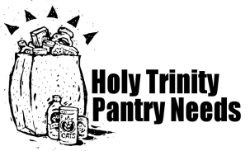
THE ST. VINCENT DE PAUL CONFERENCE at Holy Trinity will be putting up food baskets for distribution at Thanksgiving and Christmas. Our Food Pantry is in need, specifically of the following items: stuffing mix, gravy, cranberry sauce and canned vegetables, apple sauce, boxed meals, canned chicken, canned chili, canned fish, canned meats, cereals, cooking oils, crackers, canned fruits, granola bars, instant mashed potatoes, nuts, pancake mix, pancake syrup, peanut butter, soups, stews and self-stable milk . If it is easier for you any monetary donation will be greatly appreciated to help with the cost of turkeys for Thanksgiving and hams for Christmas. May God reward you hundred fold for your continued generosity to the society.
THIS WEEK’S REFLECTION: In this process of becoming “Contemplatives in Action” by finding intimacy with God in the background of our everyday busy lives, we are seeing more and more clearly that Prayer is not really “saying prayers” but is a relationship that needs to be nourished in an ongoing way. No matter how hectic our week is, it is easy to think about our daily relationship with Our Father, with Jesus, in the Holy Spirit. As we look ahead to the landscape of our week - with a few big things coming up, a host of ordinary responsibilities, and perhaps several bruised or difficult relationships that trouble us - we can begin to locate and formulate into words, the desires in our hearts for our Lord’s help along the way. Perhaps we will have time to review a Daily Reflection each day or just the readings of the day. We may only have time to have a general sense of the Word of God addressed to us - from last Sunday and what is coming up this coming Sunday. That Word will further inform and shape how we will be in an ongoing dialogue with our Lord this week. The rest is about developing the habit of focusing more intentionally on our relationship with our Lord, anticipating the events of our day, preparing for them, and letting our Lord be there in it with us. This is what it is to keep enough oil in our lamps. This is what it is to know that the presence of God is in our midst. This is what it takes to be good stewards of all that our Lord has entrusted to us. So, we ask for what we need and desire, each morning, as soon as we can. We return to that desire, in brief moments, throughout the day. At the end of our day, we give thanks for this gifted relationship that sustained us and allowed us to be his disciples this day.

