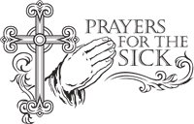
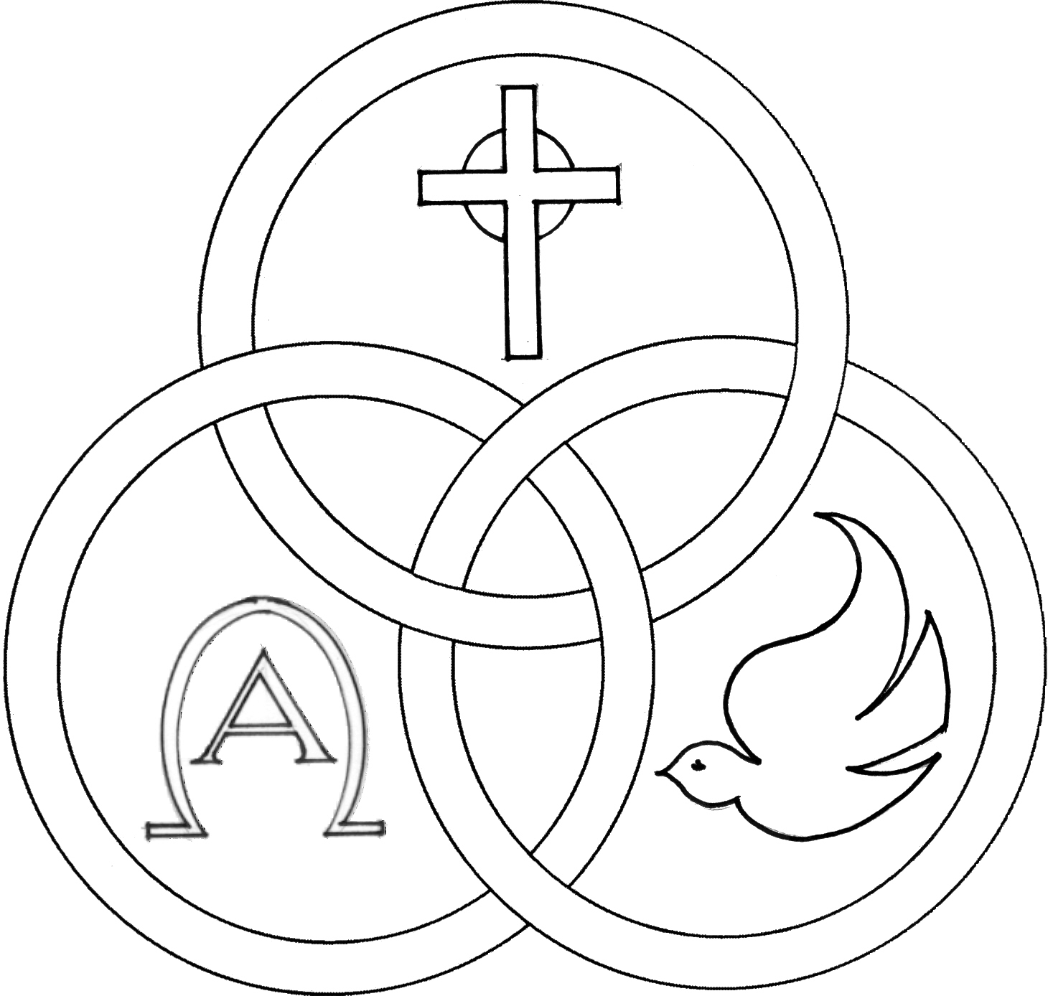
Parish of the Holy Trinity Roman Catholic Church
951Stafford Road
Fall River, Massachusetts
www.holytrinityfallriver.com

Solemnity of Pentecost

Saturday 5/23 Pentecost Sunday
4:00 pm Herman Medeiros 7th Anniversary (by Wife)
Sunday 5/24 Pentecost Sunday
8:30 am Lorraine J. Dion (by Husband & Daughters)
10:30 am Thomas Cadima

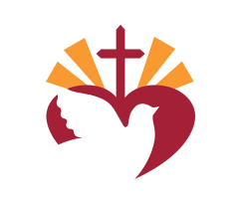
Monday 5/25 The Blessed Virgin Mary
8:30 am For all those who have died. We pray in a special way for Leo Gendreau and Barbara Platt.
Tuesday 5/26 Philip Neri, priest
8:30 am Thomas Cadima
Wednesday 5/27 Weekday
8:30 am Angie & Mary Medeiros (by Family)
Thursday 5/28 Weekday
8:30 am For the People of our parish

Saturday 5/30 The Most Holy Trinity
4:00 pm Arthur & Evelyn Silvia (by Anne Marie)
Sunday 5/31 The Most Holy Trinity
8:30 am Warren & Annette O’Connel (by Family)
10:30 am Louis & Irene Soares (by Family)

Blessed Sacrament Sanctuary Lamp:
Given this week in memory of


Lorraine J. Dion

By Husband & Daughters

Week of 5/18/25


Budget $3,798.05
Catholic Communication $1,244.00


Yellow registration forms are available on the tables inside Church, near each of the entrances. Please drop them into the collection basket at Mass and introduce yourself to Father Oliveira after Mass or call the parish office for an appointment. We hope that you feel very much at home!
PRAY FOR THE SICK OF OUR PARISH and our families especially for those in hospitals, rehabilitation centers, nursing facilities and the homebound. Pray for all those who are undergoing medical treatments at this time.


THE SECOND COLLECTION
There is no second collection this weekend.

THE 85th ANNUAL CATHOLIC APPEAL FOR THE FALL RIVER DIOCESE: “PEACE: Let it begin with me.”
The Catholic Appeal has a tremendous impact on our community as over tens of thousands of people are assisted annually across the Diocese of Fall River. We would ask that you prayerfully consider returning your donation along with your contribution card, either in the collection basket or by sending it to the Appeal office at your earliest convenience. With our third report to appeal headquarters our total so far is $8,507.00. Last year’s total was $38,487.00. EXTRA CATHOLIC APPEAL CONTRIBUTION CARDS AND ENVELOPES are available on the tables for anyone who may need one for this year’s Appeal. Thanks for all your help and generous assistance to those in need!

HOLY TRINITY YOUTH CHOIR: Sunday, June 7th the Holy Trinity Youth Choir will be singing at the 10:30 am Mass.

JUNE: The year’s end meeting of the Holy Trinity Women’s Guild will be at Barcellos on Sunday, June 7th at 1:00pm.


OUR PARISH OFFICE WILL BE CLOSED this Monday, May 25th in observance of the Memorial Day holiday. Our parish office will reopen again on Tuesday, May 26th.


NATIONAL EUCHARISTIC PILGRIMAGE
Our diocese was invited to host a portion of the National Eucharistic Pilgrimage, which will take place this June in honor of America’s 250th anniversary, concurrent with the U.S. Bishops consecration of our country to the Sacred Heart of Jesus. The “Cabrini Route” will pass through our diocese Monday, June 29th through Tuesday, June 30th, 2026. Starting Point on Tuesday, June 30th will be at Church of the Holy Name, 709 Hanover Street, Fall River, MA. Parking for morning Mass and the start of the procession will be available at Holy Name School.

7:00AM-Mass at Holy Name, followed by Exposition
8:30AM-Eucharistic Procession departs Holy Name for stops at: Chancery Campus (450 Highland) approx. 8:50
City Gates Plaza (Ponta Delgada Blvd) approx 10:15
Inside Santo Christo Parish (185 Canal St.) approx 10:45
Inside Cathedral of St. Mary (Spring St.) approx 11:30
Concluding with Benediction in Cathedral
12:00 noon Mass at at Cathedral by Bishop da Cunha.

Hospitality to follow on rear lawn of the Cathedral, concluding by 2pm.


CONGRATUALATIONS to the members of our parish who graduated from college and high school, may God be with you as you go forward to the next stage of your life.



MASS INTENTIONS

The Mass Intention Book will open for July thru December 2026 on Tuesday, May19th. In fairness to all our parishioners only 2 weekend and 4 weekdays Masses can be scheduled at this time. After June 9th you can schedule more Masses if there are still openings. You can come to the parish office or call the office at 508-672-3200 between the hours of 10:00am and 2:00pm to book Masses and sanctuary lamp.
THIS WEEK’S REFLECTION: Pentecost, and our being renewed with the gifts of the Holy Spirit, comes at the end of the Easter Season, but as the birthday of the Church, it is a fitting beginning to our return to Ordinary Time. We can continue to ask that the Holy Spirit come into our hearts, to enkindle within us the fire of the Spirit’s Love. We can continue to ask that we be able to join the Spirit in our taking up our role in renewing the face of the earth. It is so appropriate that this takes us to remembering that Mary is the Mother of the Church, our mother in this Spirit-filled process of being Church together. We can ask Mary to place us with her Son this week. We might find ourselves struggling with something or someone, here or there this week. We can turn to Jesus, in those little conversations, and feel the gift of his Spirit freeing us - as the Spirit always does - and enkindling a fire within us, which is always purifying and which always stirs love in our heart. These exercises of trust and renewal will refresh us in the times that tempt us to give in to what is cold and hard and dark. We can acknowledge the presence of the Spirit, the moment I turn for help and light and direction. And, in those moments, we can give thanks and embrace the gift. Finally, we can let ourselves look for people in our lives, on our paths, who need comforting and the warmth of the Spirit to heal them and offer them peace. I can express me desire, “Lord, I so desire to be an instrument of your Spirit’s peace and a channel for reconciliation and healing.” The Spirit will respond when we pray with that openness and desire.



