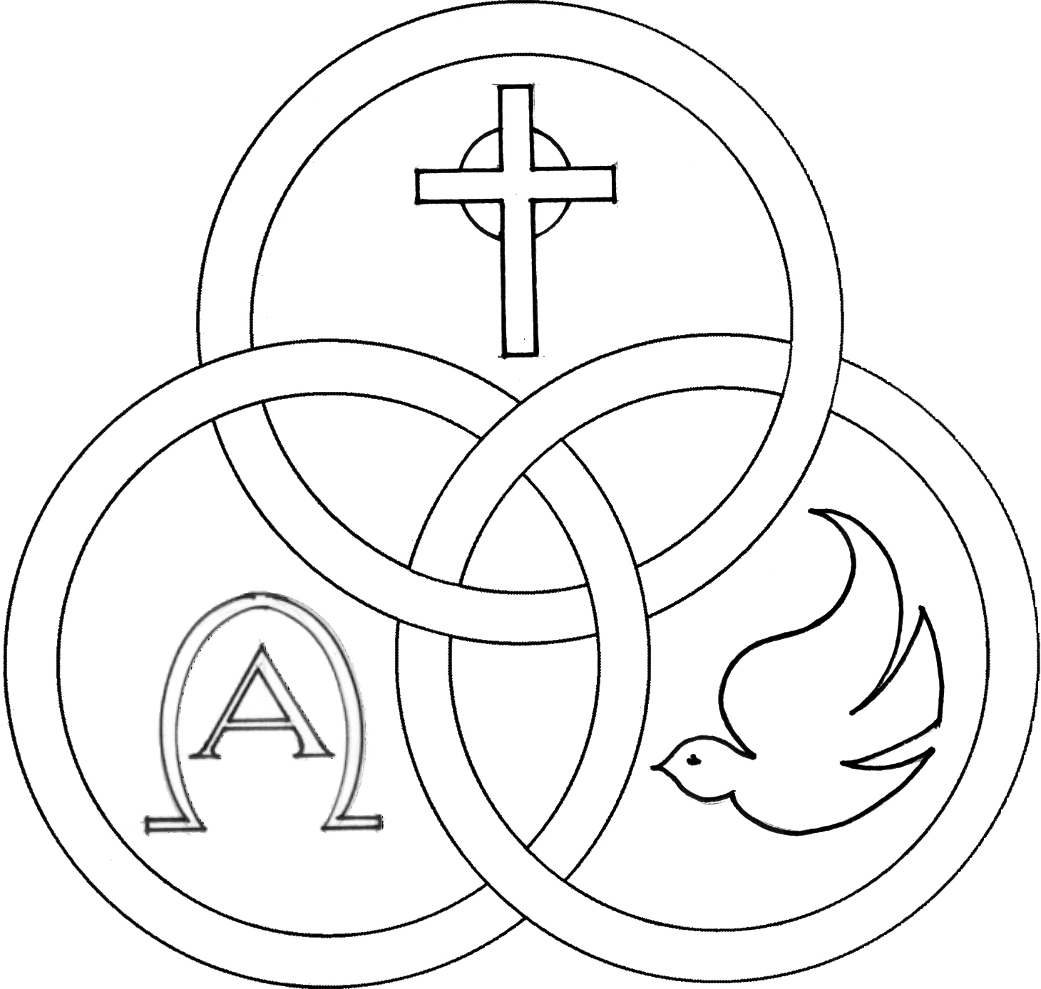
Parish of the Holy Trinity Roman Catholic Church
951Stafford Road
Fall River, Massachusetts
www.holytrinityfallriver.com
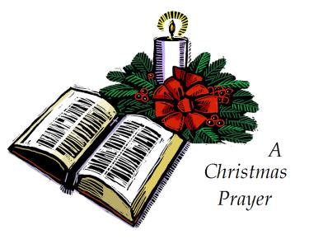
Solemnity: Epiphany of the Lord

Saturday 1/3 Solemnity: Epiphany of the Lord
4:00 pm Ray & Louise Walkden (by Lois)
Sunday 1/4 Solemnity: Epiphany of the Lord
8:30 am Arthur Pereira (by Granddaughters)
10:30 am Thomas Cadima (by Family)

Monday 1/5 John Neumann, Bishop
8:30 am Emily & Antone Pacheco (by Jan & Mike)
Tuesday 1/6 Christmas Weekday
8:30 am Thomas Cadima (by Wife)
Wednesday 1/7 Christmas Weekday
8:30 am Ludgero Tavares (by Wife & Daughter)
Thursday 1/8 Christmas Weekday
8:30 am For the People of our parish

Saturday 1/10 Feast: Baptism of the Lord
4:00 pm Francis & Laura Arruda (by Jan & Mike)
Sunday 1/11 Feast: Baptism of the Lord
8:30 am Odilia Andrade Birthday Remembrance
(by Family)
10:30 am Albert Beaudoin (by Dumont Family)

Blessed Sacrament Sanctuary Lamp:
Given this week in memory of

Thomas Cadima

By Wife

Week of 12/28/25

Budget $3,406.00

Assessment $1,933.00


Yellow registration forms are available on the tables inside Church, near each of the entrances. Please drop them into the collection basket at Mass and introduce yourself to Father Oliveira after Mass or call the parish office for an appointment. We hope that you feel very much at home!
FROM THE PASTOR THANK YOU to the many people for your Christmas wishes and blessings and for the cards, gifts and goodies. They were greatly appreciated.

THANKS TO ALL our parishioners and friends who generously donated $8,130.00 for the Christmas collection for our parish. Thank you for your Christmas gift to our parish and thank you for your faithful support throughout the year.


THE SECOND COLLECTION this weekend is to help assist our parish with snow and ice removal from all of our parking lots, walkways and sidewalks during the winter season. Thank you for all your help and support.


CHRISTMAS FLOWER MEMORIAL THANK YOU for contributing $12,790.00 towards our Christmas Flower Memorial. Because of your generosity we were able to have some very beautiful decorations for the Christmas Season. It is a most beautiful tribute to our loved ones and friends. May the Lord grant them eternal joy and happiness!


THE CHRISTMAS SEASON will conclude next Sunday, January 11th, the feast of the Baptism of the Lord. May our celebration of Christ’s birth enable us to welcome the God who dwells among us!


THANK YOU A VERY SPECIAL THANKS to our women’s guild who has given a $3,700.00 gift to our parish. With the fundraisers our guild has been able to raise some much needed funds for our parish. We thank all the officers and members of our guild for their very generous gift, as well as, for all their hard work and effort. We are most appreciative to them for all that they do for our parish. Thanks also to the members of our parish family that have supported the activities of Holy Trinity Women’s Guild.


RELIGIOUS EDUCATION We wish all our students, their families and our Catechists all the Blessings of this Holy Season. Classes will resume this Sunday, January 4th 2026.


HOLY TRINITY YOUTH CHOIR: Next Sunday, January 11th the Holy Trinity Youth Choir will be singing at the 10:30am Mass.


LECTOR & EUCHARISTIC
MINISTER SCHEDULES
The schedules are ready and will be in the sacristy this weekend for the EM’s and Lectors to pick up at all Masses.

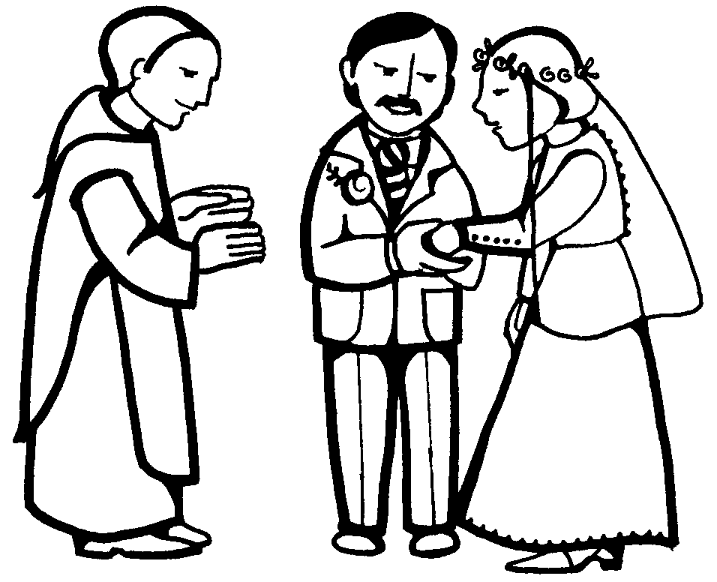
WEDDING ANNIVERSARY CELEBRATION: The Annual Diocesan Wedding Anniversary Celebration will be celebrated with a special Mass of Thanksgiving for couples observing significant wedding anniversaries (including first year). Renew your wedding vows with the Bishop of Fall River on Sunday, February 8, 2026, at 3:00 p.m. at St. Mary Cathedral in Fall River. If you would like an invitation, please call the parish office as soon as possible. The registration deadline for this event is January 16, 2026.

A CHRTISTMAS FLOWER MEMORIAL for those names who did not make it on our memorial bulletin a page has been added that can be inserted into the 2025 memorial. Copies of this memorial can be found at all the entrances of Church.

FOR ALL THOSE WHO WOULD LIKE a plant from our Christmas display, they will be available after the 10:30am Mass NEXT Sunday. Plants will be distributed right after Mass on a first come/ first serve basis. For reasons of good order and fairness we ask that all those who would like a plant, please be seated in the pews directly in front of the Lectern and a plant will be brought to you.
THIS WEEK’S REFLECTION: This week is a time with two special Sundays book-ending the week. Both celebrations offer an “epiphany,” an understanding and insight into the essence of who Jesus really is. When the Wisemen visit the poorest of families and find the baby Jesus, they have a clearer idea of what kind of king he will be. At the Baptism of the Lord the following Sunday, Jesus is baptized and the skies open and the voice of God proclaims, “This is my beloved Son.” More than just a prophet, this special relationship with God is made manifest in that moment. How can we make this week a special one as the Christmas season draws to a close? In some parts of the world daylight is plentiful right now, but for many of us the days are short and the dark of night surrounds us many hours each day. This could be the week to reflect on that darkness and the light that Jesus brings into our hearts. Each morning as our feet touch the floor next to our beds, we can open our hands briefly in the darkness and ask God to show us the light in our lives. Gratitude is a wonderful way to pray and to recognize the light we sometimes don’t notice in our lives. Maybe in this final week of Christmas, we can light a candle at dinner and remember a special blessing we have been given or something we are grateful for in our lives.
Dear Lord,
You came to your disciples when they felt alone on the stormy waters and comforted them with your presence. Be with me today and let my heart be touched by the the love you so lavishly give to me. Let me remember to turn to you in my fears and darkness and know that you will heal me.

