
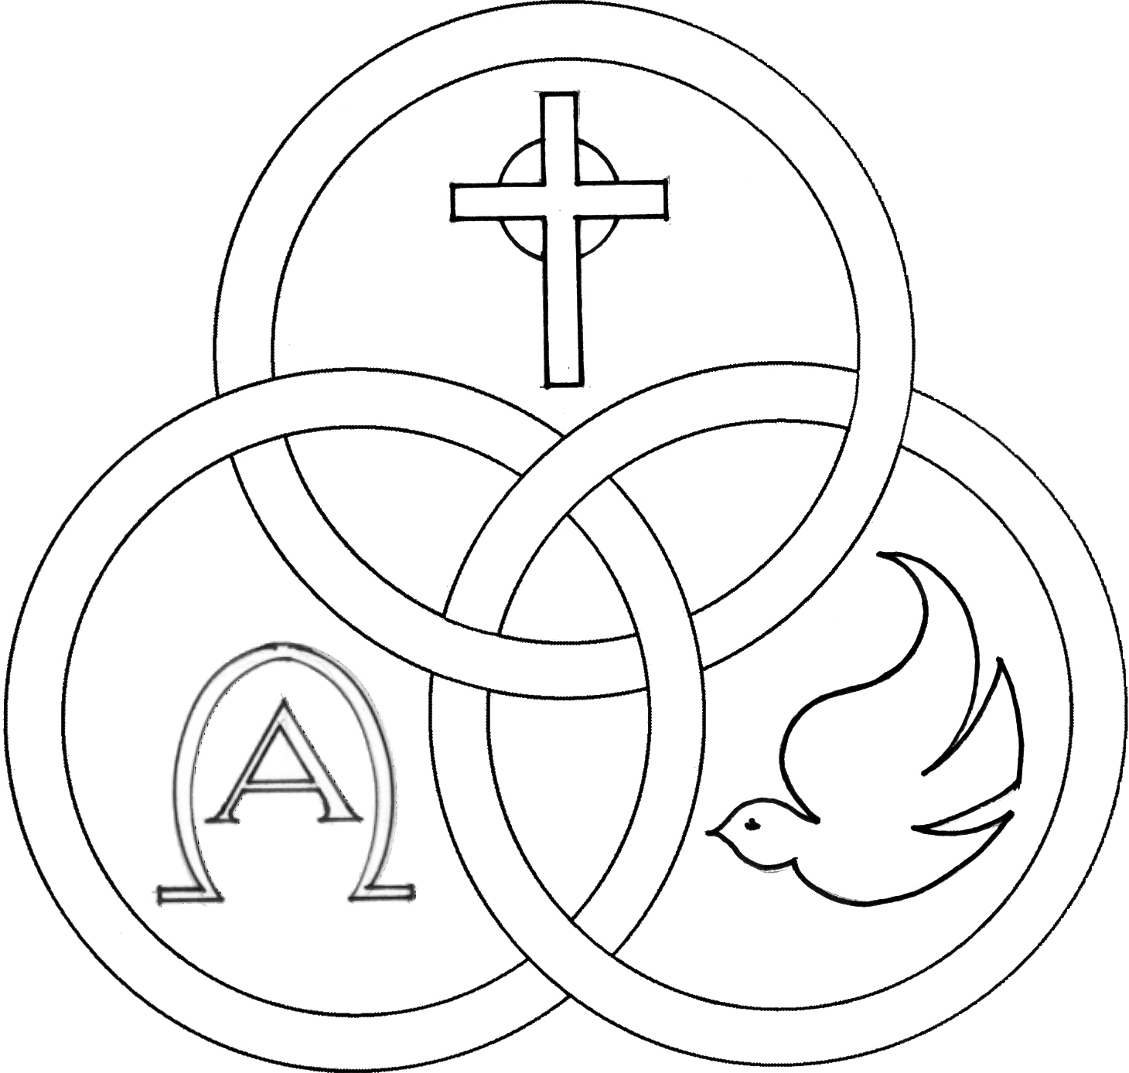
Parish of the Holy Trinity Roman Catholic Church
951Stafford Road
Fall River, Massachusetts
www.holytrinityfallriver.com

Second Sunday in Ordinary Time

Saturday 1/ 17 2nd Sunday in Ordinary Time
4:00 pm Frank & Olive Medeiros (by Family)
Sunday 1/18 2nd Sunday in Ordinary Time
8:30 am M/M Clementino Oliveira (by Daughters)
10:30 am Anna Canuel (by Family)

Monday 1/19 Weekday
8:30 am Biatriz & Manuel Oliveira (by Daughter)
Tuesday 1/20 Weekday
8:30 am For the People of our parish
Wednesday 1/21 Agnes, virgin & martyr
8:30 am Laura Arruda (by Holy Trinity Women’s Guild)
Thursday 1/22 Prayer for Protection of the Unborn
8:30 am Emily & Antone Pacheco (by Jan & Mike)

Saturday 1/24 3rd Sunday in Ordinary Time
4:00 pm Teddy Karcz (by Wife & Family)
Sunday 1/25 3rd Sunday in Ordinary Time
8:30 am Robert Benevides 2nd Anniversary
(by Family)
10:30 am Fr. Dave Andrade (by Family)

Blessed Sacrament Sanctuary Lamp:
Given this week in memory of


Biatriz & Manuel Oliveira

By Daughter

Week of 1/11/26

Budget $4,540.00

Maintenance $2,202.00


Yellow registration forms are available on the tables inside Church, near each of the entrances. Please drop them into the collection basket at Mass and introduce yourself to Father Oliveira after Mass or call the parish office for an appointment. We hope that you feel very much at home!
PRAY FOR THE SICK OF OUR PARISH and our families especially for those in hospitals, rehabilitation centers, nursing facilities and the homebound. Pray for all those who are undergoing medical treatments at this time.


THE SECOND COLLECTION.
this weekend is to help assist our parish with the substantial fuel and heating costs that we incur during the fall and winter seasons. Thank you so very much for all your support!


PLEASE REMEMBER IN YOUR PRAYERS Brunette Beaudoin whose funeral was celebrated in our parish. We extend our prayerful support to her family and friends. May her soul and the souls of all the faithful departed, through the Mercy of God rest in peace. Amen.


HOLY TRINITY YOUTH CHOIR: Next Sunday, January 25th to kick-off Catholic School Week, the Holy Trinity Youth Choir will be singing at the 10:30 am Mass.

SHOWER FOR THE HOMELESS: In collaboration with the Catholic Social Services of the Fall River Diocese and the Holy Trinity Women's Guild we are collecting NEW ITEMS ONLY; Men, Women and Children; socks, hats, gloves, mittens, scarves, and toiletries. Please place items in the baskets at the entrances of the church. Thank you.


OUR PARISH OFFICE WILL BE CLOSED THIS MONDAY, January 19th in observance of the Martin Luther King, Jr. holiday. Our office will reopen on Tuesday January 20th.


RELIGIOUS EDUCATION.
There will be no classes THIS Sunday, January 18th due to the Martin Luther King Holiday. Classes will resume on Sunday, January 25th.


THE SACRAMENT OF CONFIRMATION will be celebrated on Tuesday, March 3, 2026 at 7pm here at Holy Trinity by Bishop Edgar da Cunha. Please keep in your prayers all those who are preparing to receive the sacrament of Confirmation.


CATHOLIC SCHOOL WEEK this year is the week of January 25th. Please keep our school, teachers, staff and students in your thoughts and prayers. More information will be in upcoming bulletin announcements.


OFFICE OF SAFE ENVIRONMENT All members of the clergy, Directors of Religious Education and teachers in our schools are Mandated Reporters in Massachusetts and required by law to report any suspected child abuse. Many children will not tell anyone they are being abused. Because the Diocese believes in our moral obligation to protect children, we extend the safe environment training to all who minister, work or volunteer. Watch for signs of abuse and, if you are concerned about a child, share those concerns with a mandated reporter at your parish or school. Let us all be a voice for children who may not be able to speak for themselves.


FR. BOB’S REFLECTIONS can still be found on facebook at Holy Trinity Parish Fall River MA or our website at holytrinityparishfallriver.com daily beginning at 7:35am.

THIS WEEK’S REFLECTION: Ordinary Time is the longest Season of the Church year. This year we have only a few weeks of Ordinary Time until Lent begins. These weeks between the Christmas season and Lent are an important time to continue to work on our habits of focusing our desires early in the day and talking with the Lord throughout the day, in the background of our busy lives. This is how we become “Contemplatives in action” and find intimacy with God without leaving the context of our real lives. How do we do that with the hectic pace of our lives? We hear people say “I don’t have time to pray.” It isn’t about finding more time but more focus in our day with God. With this type of focusing and active consciousness, we find ourselves surprised at the time we really do have. There are dozens of times in all of our days during which our minds are occupied with something: a song, re-playing the last event, practicing a conversation with someone, having an imaginary argument with someone, thinking through the “to do” list of the day. We can learn to fill these times with whatever we choose. If we choose to let it be about our relationship with our Lord, it transforms our lives. It all begins with our mornings. This week, when we first get up and perhaps for a few moments in the shower or getting dressed, let’s tell the Lord that what we desire today is to be more conscious of how what we do this day is responding to his call to me to be his disciple. Then, during the day, in those moments while driving or shopping or walking down the hall to a meeting, we can talk about how we are living our call in this or that activity we are engaged in. That conversation may get more detailed and specific in this or that set of events. Each evening, for even a few moments, we can review our day’s momentary conversations, recognizing the moments of real connection and grace and giving thanks for them, and resolving to take even greater advantage of these opportunities the next day.


