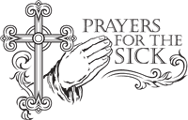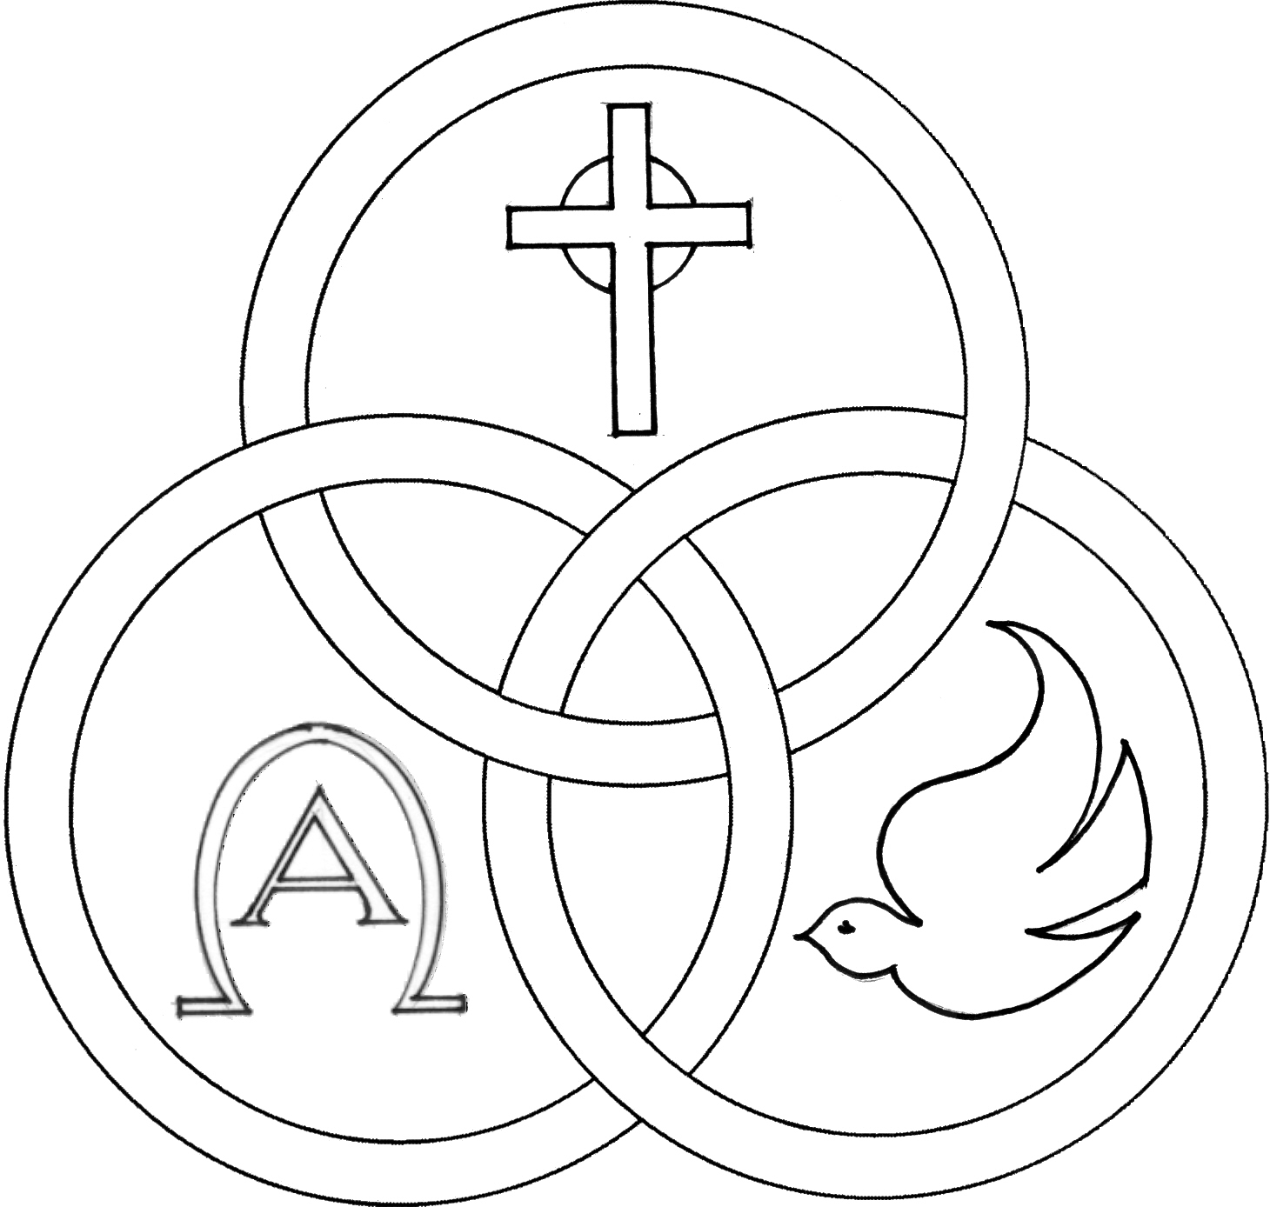**Parish of the Holy Trinity** *Roman Catholic Church*

951Stafford Road

Fall River, Massachusetts

[**www.holytrinityfallriver.com**](http://www.holytrinityfallriver.com)

***Twenty-first Sunday in Ordinary Time***

**Saturday 8/23 21st Sunday in Ordinary Time**

4:00 pm Andre Bernier *(by Wife & Family)*

**Sunday 8/24 21st Sunday in Ordinary Time**

8:30 am Miriam Trindade & Djanira DeTorres

*(by Niece)*

10:30 am Maria deJesus & Antonio Gervasio *(by Daughters)*



**Monday 8/25 Weekday**

8:30 am For the People *of our parish*

**Tuesday** **8/26 Weekday**

8:30 am Raymond C. & Diane C. Mello

*(by Friends from Little Compton)*

**Wednesday8/27 Monica**

8:30 am For all those who have died. *We pray in a special way for Maria Sousa, Elizabeth Costa, Monica Giannotti and Joan Boudria.*

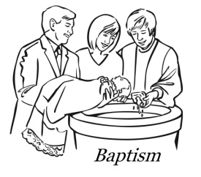**Thursday 8/28 Augustine,** bishop & doctor

8:30 am Silvester, Maria & David Daluz &

Steve & Christopher Perry *(by Family)*

**Saturday 8/30 22nd Sunday in Ordinary Time**

4:00 pm Irene & Louis Soares

**Sunday 8/31 22nd Sunday in Ordinary Time**

8:30 amLorraine & Raymond Francoeur *(by Family)*

10:30 am Kenneth Furtado 6th Anniversary

*(by Wife & Family)*

ISCBC005 **Blessed Sacrament Sanctuary Lamp:**

*Given this week in memory of*

Maria deJesus, Antonio Gervasio

& Family

By Daughters

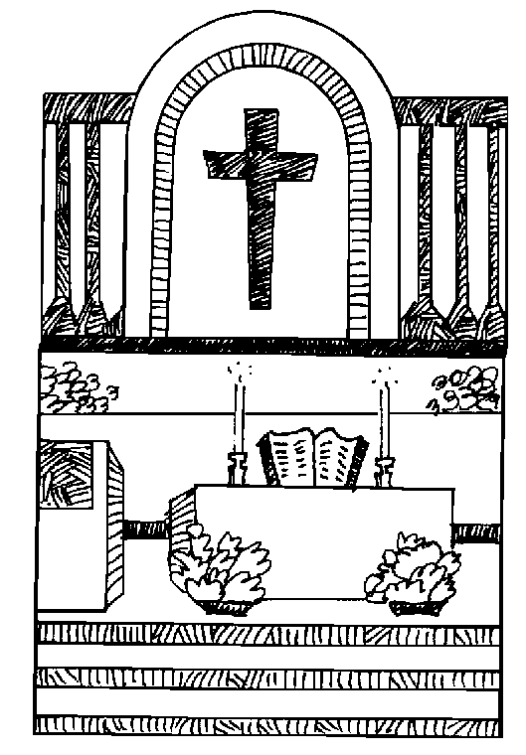

**CSOFT003 Week of 8/17/25**

**Budget $3,860.00**

**Assessment $2,334.00**

**PRAY FOR THE SICK OF OUR PARISH** and our families especially for those in hospitals, rehabilitation centers, nursing facilities and the homebound. Pray for all those who are undergoing medical treatments at this time.

**THE SECOND COLLECTION** this weekendwill be taken up to help defray the cost of our Church air conditioning.Thank you so much for your generous support!

**PLEASE REMEMBER IN YOUR PRAYERS Monica Giannotti and Joan Boudria** whose funerals were celebrated in our parish. We extend our prayerful support to their families and friends. *May their souls and the souls of all the faithful departed, through the Mercy of God rest in peace. Amen.*

**WE WELCOME Jameson Patrick Connelly, Donovan Augustine Sanda, Deirdre Morgan Sanda and Othelia Emerick Sanda** into our parish family through the Sacrament of Baptism. We extend our congratulations and prayerful support to their parents and family. **A very special welcome to the newest members of our parish family.**

**FAUSTINA CENTER:**

The Faustina Center, located in Fall River, run by the Fall River Diocese. The Faustina Center is an Island of Mercy for Families, who face difficult pregnancies through free resources: providing education, material resources, spiritual support and community referrals. A baby shower will be planned in the upcoming weeks. A flier has been provided with more info on the center and are located near the bulletins.

A Mass of Remembrance will be celebrated in the Mausoleum Chapel at Notre Dame Cemetery in Fall River on Saturday, August 30, 2025, at 9:00 a.m. A Mass of Remembrance will also be celebrated on Sunday, August 31, 2025, at St. John Neumann Church in East Freetown at 10:00 a.m

**THE RELIGIOUS EDUCATION OFFICE**. Any new students enrolling for First Communion or Confirmation program will need to register. Students already enrolled in classes 3-7 will automatically be bumped up to the next grade. Registration forms will be available by seeing Fr. Bob after mass.

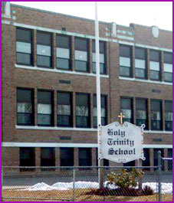**NEW SCHOOL YEAR** Holy Trinity School will begin the academic year on Tuesday, August 26th. Please note the first 3 days of school are ½ days and dismissal will be at 11:30am. As we begin this new school year, please remember our students, faculty and staff in your

prayers and please know that whatever you can do to help support our school throughout the year is most gratefully appreciated! Also please keep in your prayers all our high school and college students as they begin the 2025-2026 academic year.

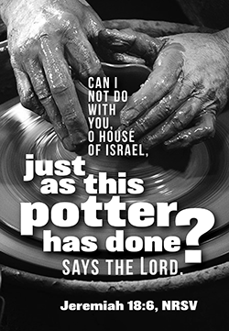Holy Trinity School is looking for someone who has experience with pottery, pottery wheels and kilns, who would be interested in teaching an afterschool class. If you are interested please contact Brenda Gagnon, school principal, at bgagnon@htfr.dfrcs.org or 508-673-6772.

**THIS WEEK’S REFLECTION:** The old Baltimore Catechism defined Prayer as “raising the mind and heart to God.” It reminds us that prayer is not simply saying words to God, or even thinking over religious things in our heads. Real prayer becomes a matter of the heart. We understand prayer best when we think of it as a relationship. Growing in prayer is to grow in love, in intimacy, in a type of communication that is “heart to heart.” So, on the human level, if we have a difficult time receiving love or in surrendering our self-absorption and giving love or if we just haven’t had much experience of being intimate and vulnerable with another human being, then it will be difficult for us to do that with God. Conversely, anything we can do to develop our relationship skills, to de-selfish ourselves and practice accepting love and loving generously will help us grow in our relationship with God. Praying can often become easier, more personal and intimate. This week, we can go from hearing these wonderful readings to listening to Jesus with our hearts. It is great to begin this week asking for the grace to reflect throughout the day on how we will enter “the narrow gate”, by how we go about our day, interact with people, or return home from work. Then we can reflect on how we can humble ourselves and what that means for our day-to-day choices. We could ask for the grace to go deeper than the externals and rules and get to the heart of our faith - loving others with the same compassion and love that Jesus shows us. For some of us, it might be extremely helpful this week to take the word “awake” and to carry it all day long. “Help me stay awake, Lord: to be alert and attentive, focused and reflective today. It will be busy, but I ask that you help me be consciously aware that you will be with me all day.” We may want to ask, “Lord, let me be conscious of the many gifts and blessings you have given me. Let me reflect upon how I use each gift gratefully and for others. Let me really see today if there are gifts that I am neglecting, squandering, or simply are afraid to use. Then, give me the courage to give you thanks and to be a good steward of your gifts.” As we prepare for Sunday, we can begin to reflect upon giving up the honors in our lives. We can begin each day praying, “Lord, help me humble myself today, put myself last in caring for my family, in doing my job with a more selfless sense of service. Help me forgive people who aren’t performing well or behaving well. Help me see the way you give me life in this surrender, in this freedom to spend brief moments today in talking with you, friend-to-friend, in heart-felt connection with you, for others.”