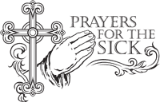
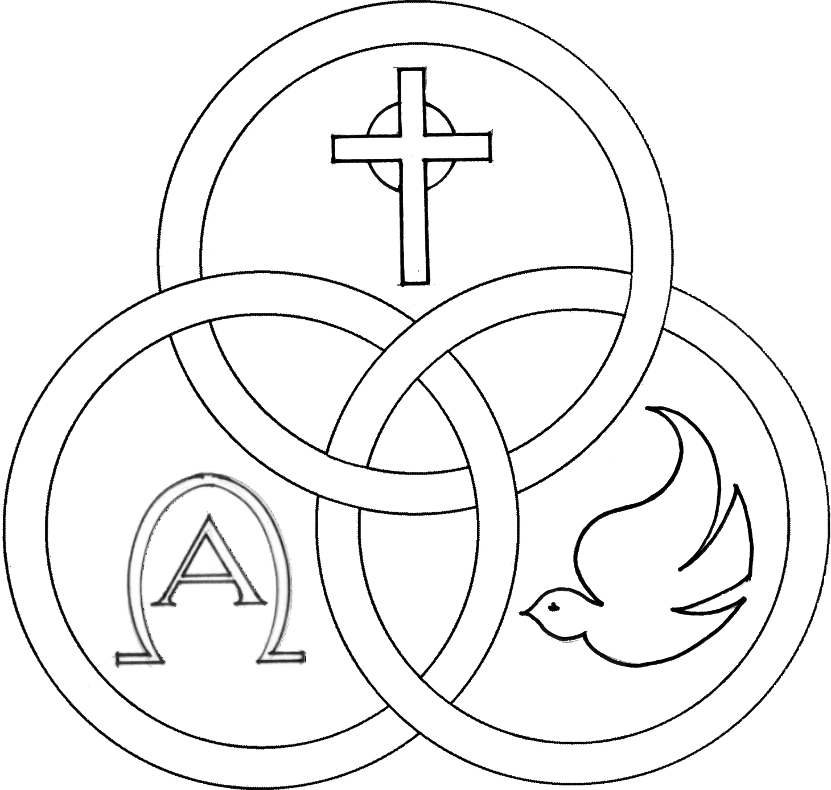
Parish of the Holy Trinity Roman Catholic Church
951Stafford Road
Fall River, Massachusetts
www.holytrinityfallriver.com

Commemoration of All Souls

Saturday 11/1 Commemoration of All Souls
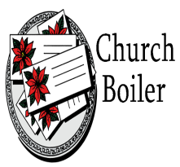
4:00 pm Teddy Karcz (by Sandy)
Sunday 11/2 Commemoration of All Souls
8:30 am Vasco & Maria Araujo (by Family)
10:30 am Jose Andrade Birthday Remembrance
(by Family)

Monday 11/3 Weekday

8:30 am Odelia, Albert, Henry & Joe Medeiros (by Family)
Tuesday 11/4 Charles Borromeo, bishop
8:30 am Donald Chouinard (by Aunt Gert & Family)
Wednesday 11/5 Weekday
8:30 am Edward Medeiros
Thursday 11/6 Weekday
8:30 am For the People of our parish

Saturday 11/8 Dedication of the Lateran Basilica
4:00 pm Ludgero Tavares 12th Anniversary
(by Wife & Daughters)
Sunday 11/9 Dedication of the Lateran Basilica
8:30 am Dorothy Chaves 5th Anniversary
(by Family)
10:30 am John Albernaz & Parents (by Family

Blessed Sacrament Sanctuary Lamp:
Given this week in memory of

Fr. John Perry

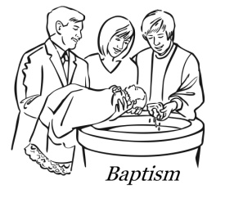

Week of 10/26/25

Budget $4,149.10

Music Ministry $1,969.75


Yellow registration forms are available on the tables inside Church, near each of the entrances. Please drop them into the collection basket at Mass and introduce yourself to Father Oliveira after Mass or call the parish office for an appointment. We hope that you feel very much at home!
PRAY FOR THE SICK OF OUR PARISH and our families especially for those in hospitals, rehabilitation centers, nursing facilities and the homebound. Pray for all those who are undergoing medical treatments at this time.

THE SECOND COLLECTION
this weekend is to help towards the funds used to install our Church boiler. Thank you for all your generosity and support!

THE SOLEMNITY OF ALL SAINTS, because All Saints day falls on a Saturday this year it is not a holyday of obligation. However there is an envelope offered in your packet you received with your Sept./Oct. mailing.


MONTH OF NOVEMBER PRAYER BOX ON ALTAR contains the All Souls envelopes and names submitted to the parish for prayers during the month of November. The names of our beloved deceased will be remembered throughout the month of November and the prayer box will be on the altar of sacrifice or the altar of repose (the tabernacle) throughout November. Anyone who would like to add a list of names, please give them to Father Oliveira.

WE WELCOME Evonna Maria Paiva into our parish family through the Sacrament of Baptism. We extend our congratulations and prayerful support to her parents and family. A very special welcome to the newest member of our parish family.


NOVEMBER MEETING: A meeting of Holy Trinity Women’s Guild will be held Monday, November 3rd at 6:00 pm in the Church Hall to finalize plans for the Fall Auction of 2025. All are welcome.

THE RELIGIOUS EDUCATION OFFICE: Religious Formation
Grades 3-7 will continue to be presented online via FACEBOOK at Holy Trinity Parish Fall River. First Communion (grades 1-2) and Confirmation classes (grades 8-9) will be held in person in the parish church and parish center following the 8:30 Sunday liturgy. Kindly note we do require in writing baptismal information for our students. As in the past class notes and Sunday preparation materials will be forwarded to each student via email.


THE HOLY TRINITY WOMEN'S GUILD "TAKE A CHANCE AUCTION & FOOD FEST" Holy Trinity Women’s Guild will once again sponsor an auction on Saturday, November 8th and Sunday, November 9th in the Church Hall. Tickets and Treats for sale on Saturday between 3:00pm & 6:00pm. On Sunday Tickets for sale 9:15am to 1:00pm. Food for sale “Eat In or Take Out” 11:30am to 1:00pm. Drawings to be held on Sunday, November 9th at 1:00pm. Winners need not be present to win. Please come and support your parish.


OPEN HOUSE Bishop Stang, a Catholic, college preparatory high school in Dartmouth, MA welcomes parents and students of all middle school grades to attend an Open House Event on Wednesday, November 5th from 6:30pm.

Faculty and students are excited to highlight all that makes Bishop Stang an outstanding faith-based, college preparatory program. Pre-register at bishopstang.org.


MASS ATTENDANCE The Diocese of Fall River has requested that the parishes of the diocese report weekend Mass attendance during the month of November. These numbers are important and the data will be sent in to the diocese in December. As always, Thank You for your attendance and participation here.
THIS WEEK’S REFLECTION: This week guides us deep into our faith in several ways. All Souls day gives us the opportunity to remember and pray for all our brothers and sisters who have died. We confidently hope and pray that they may be embraced by the love and mercy of God, poured forth in the life-giving death and resurrection of Jesus. This is a wonderful day to name all those we want to pray for, and to include in our prayer those who have no one to pray for them. As we go about our very busy lives this week, we can continue to practice focusing our attention on an ongoing conversation with our Lord throughout the day. Our desires - for union with our Lord, to know God’s love for us, to become more aware of our failings, to become more generous with our family and friends, to be more patient and forgiving, to love as we have been loved - can be expressed in these simple expressions. These expressed desires will naturally interact with the real events of our day. The gospels this week will draw us into desiring to be more merciful and to not let money or pride dominate our behavior. We won’t be “unprepared” if we keep making openings for our Lord to enter the ordinary moments of our days. In repeated moments, we can simply open our hearts and ask God for the desire to have our lives focus on God’s desires for us, rather than what our culture wants us to focus on so constantly. Each night let’s look back over the day briefly, and give thanks for a God who listens to our desires.


HOLY TRINITY PARISH SOUP KITCHEN will be held this Thursday, November 6th in our Church Hall. We welcome everyone to come and share a meal with us. Doors open at 5:00pm and close at 6:00pm. Please share the word that all are most welcome to come.

