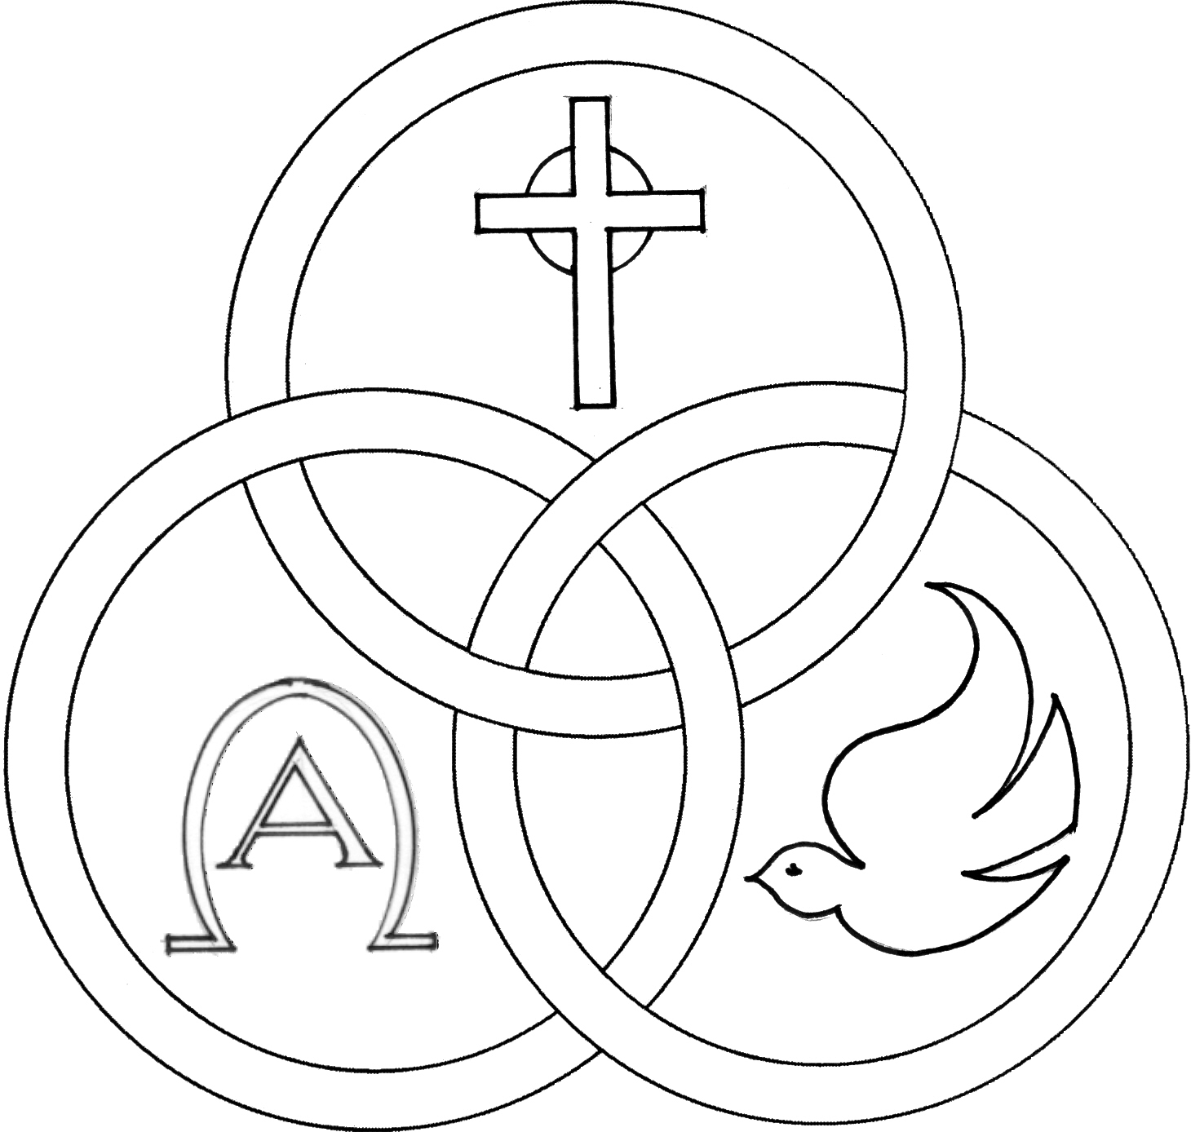
Parish of the Holy Trinity Roman Catholic Church
951Stafford Road
Fall River, Massachusetts
www.holytrinityfallriver.com

Solemnity of the Holy Trinity

Saturday 5/30 Solemnity of the Holy Trinity
4:00 pm Arthur & Evelyn Silvia (by Anne Marie
Sunday 5/31 Solemnity of the Holy Trinity
8:30 am Warren & Annette O’Connel (by Family)
10:30 am Louis & Irene Soares (by Family)

Monday 6/1 Justin, Martyr
8:30 am Celeste Peters (by Parents)
Tuesday 6/2 Weekday
8:30 am Manuel M. Oliveira (by Daughter)
Wednesday 6/3 Charles Lwanga and Companions Martyrs
8:30 am Alves Family
Thursday 6/4 Weekday
8:30 am For the People of our parish

Saturday 6/6 The Body & Blood of Christ

4:00 pm Victorino Soares Jr. (by Wife & Family)
Sunday 6/7 The Body & Blood of Christ
8:30 am Wayne Pollard (by Daughters)
10:30 am Joseph Resendes (by Louise & Family)

Blessed Sacrament Sanctuary Lamp:
Given this week in memory of

Gilbert Faria

By Madeline & Family

Week of 5/24/25

Budget $4,197.25


Yellow registration forms are available on the tables inside Church, near each of the entrances. Please drop them into the collection basket at Mass and introduce yourself to Father Oliveira after Mass or call the parish office for an appointment. We hope that you feel very much at home!

THE SECOND COLLECTION
this weekend is the monthly collection for maintenance and expense reduction for our parish. Thank you for all your generosity.


PLEASE REMEMBER IN YOUR PRAYERS Diane Cote whose funeral was celebrated in our parish. We extend our prayerful support to her family and friends. May her soul and the souls of all the faithful departed, through the Mercy of God rest in peace. Amen.

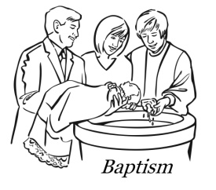
WE WELCOME Davina Costa, Drew Costa and Amias Thompson into our parish family through the Sacrament of Baptism. We extend our congratulations and prayerful support to their parents and families. A very special welcome to the newest members of our parish family.

THE 85th ANNUAL CATHOLIC APPEAL FOR THE FALL RIVER DIOCESE: “PEACE: Let it begin with me.”
The Catholic Appeal has a tremendous impact on our community as over tens of thousands of people are assisted annually across the Diocese of Fall River. We would ask that you prayerfully consider returning your donation along with your contribution card, either in the collection basket or by sending it to the Appeal office at your earliest convenience. With our fourth report to appeal headquarters our total so far is $15,917.00. Last year’s total was $38,487.00. EXTRA CATHOLIC APPEAL CONTRIBUTION CARDS AND ENVELOPES are available on the tables for anyone who may need one for this year’s Appeal. Thanks for all your help and generous assistance to those in need!


HOLY TRINITY YOUTH CHOIR: Sunday, June 7th the Holy Trinity Youth Choir will be singing at the 10:30 am Mass.


JUNE: The year’s end meeting of the Holy Trinity Women’s Guild will be at Barcellos on Sunday, June 7th at 1:00pm.

CONGRATUALATIONS to the members of our parish who graduated from college and high school, may God be with you as you go forward to the next stage of your life.


NATIONAL EUCHARISTIC PILGRIMAGE
Our diocese was invited to host a portion of the National Eucharistic Pilgrimage, which will take place this June in honor of America’s 250th anniversary, concurrent with the U.S. Bishops consecration of our country to the Sacred Heart of Jesus. The “Cabrini Route” will pass through our diocese Monday, June 29th through Tuesday, June 30th, 2026. Starting Point on Tuesday, June 30th will be at Church of the Holy Name, 709 Hanover Street, Fall River, MA. Parking for morning Mass and the start of the procession will be available at Holy Name School.

7:00AM-Mass at Holy Name, followed by Exposition
8:30AM-Eucharistic Procession departs Holy Name for stops at: Chancery Campus (450 Highland) approx. 8:50
City Gates Plaza (Ponta Delgada Blvd) approx 10:15
Inside Santo Christo Parish (185 Canal St.) approx 10:45
Inside Cathedral of St. Mary (Spring St.) approx 11:30
Concluding with Benediction in Cathedral
12:00 noon Mass at at Cathedral by Bishop da Cunha.

Hospitality to follow on rear lawn of the Cathedral, concluding by 2pm.



LUMEN CHRISTI CATHEDRAL GALA: This year’s Lumen Christi Cathedral Gala will take place on Wednesday, June 3, 2026 at White’s of Westport. The Lumen Christi Cathedral Gala focuses our collective attention on the restoration of the Cathedral. Propelled by great faith and energy led by Co-Chairs Angela Barcelos and Carl Sawejko, this year’s event will continue this critical effort. Attorney Michael J. Murray of New Bedford will serve as our Emcee for the evening. This year, The Honorable Thomas M. Quinn III will be honored for his faith, service and philanthropy.
Visit www.catholicfoundationsema.org/cathedral-gala or scan the QR code to purchase tickets online. For more information or questions, email events@catholicfoundationsema.org or call 508-617-5306
THIS WEEK’S REFLECTION: This is a week we can look at letting go -- of riches, honors, pride. In these days we can hand it all over to Jesus and ask for the trust we need in our lives. We can hand over our fears and jealousy, our titles and our possessions - anything that has become too important in our lives can get in the way of how close we allow ourselves to be with Jesus. As we go through our week, in the smallest moments of the day, we can beg Jesus for the strength of the Holy Spirit in our lives. As we awaken in the morning, and in the everyday moments of our lives, an awareness of our desires before Jesus can change our attitudes toward these chores and see them as sacred moments of invitation from the God who loves us with such fire and compassion. Dear Lord, you know how filled I am with fears. Let each moment of anxiety today be a reminder to open my life, my heart and my soul to the love and courage you offer me. I know that if only I could trust in you more, it would change my life. I beg you to give me the wisdom and strength I need to trust more and to fear less. Teach me that it’s OK to stop clinging to the fears I have known for so long and that I can embrace the freedom you offer me. Let me be less fear-ful and more generous. And all day long, as we run our errands or sit at our desks, we can take a moment to say “Thank you” to the God on whom we have such an utter dependence and who loves us with such abandon.

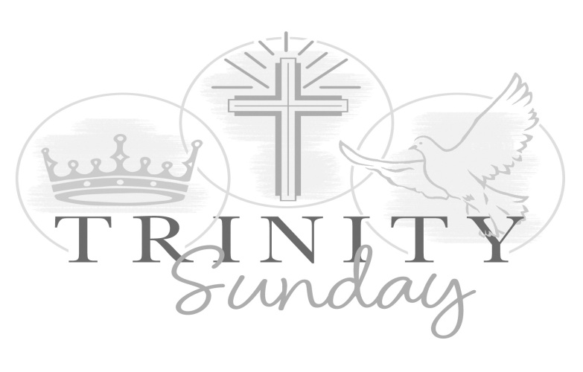

HOLY TRINITY PARISH SOUP KITCHEN will be held this Thursday, June 4th in our Church Hall. We welcome everyone to come and share a meal with us. Doors open at 5:00pm and close at 6:00pm. Please share the word that all are most welcome to come.

