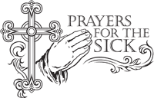
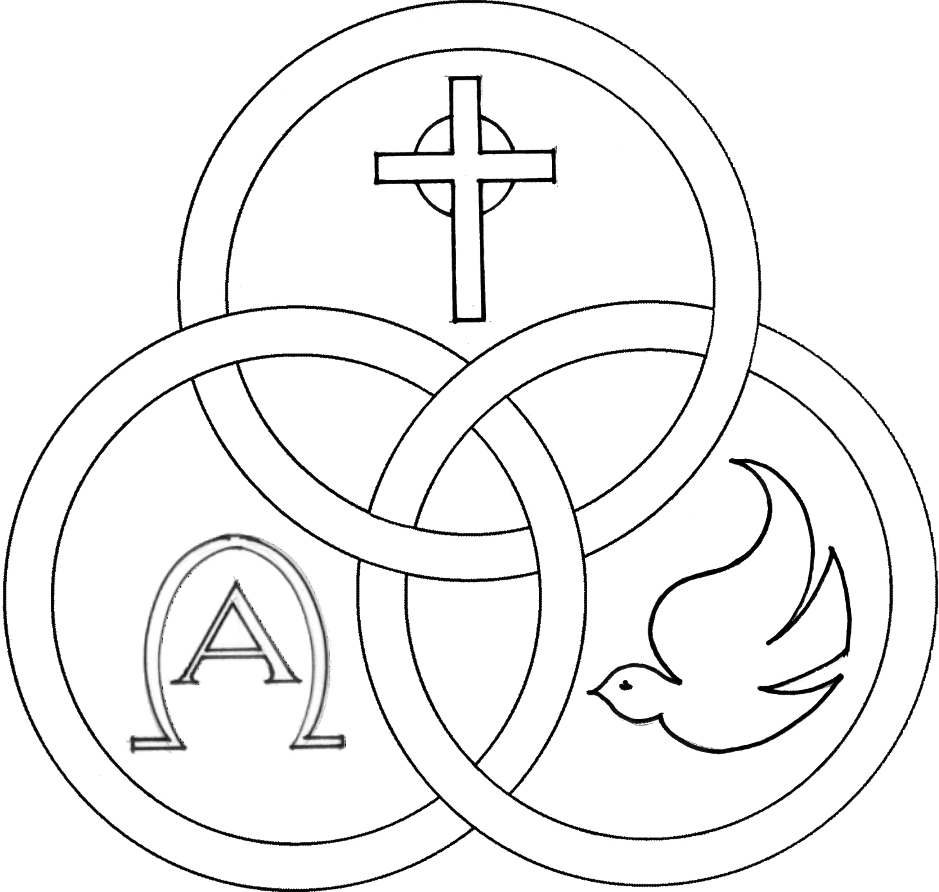
Parish of the Holy Trinity Roman Catholic Church
951Stafford Road
Fall River, Massachusetts
www.holytrinityfallriver.com

Fifth Sunday of Lent

Saturday 3/21 5th Sunday of Lent
4:00 pm Megan Elizabeth Vieira 39th Anniversary
(by Mom)
Sunday 3/22 5th Sunday of Lent
8:30 am Linda Riley Birthday Remembrance
(by Daughter)
10:30 am Tony, Joe, John & Tyler Gervasio
(by Family)

Monday 3/23 Lenten Weekday
8:30 am Odelia & Albert Medeiros (by Family)
Tuesday 3/24 Lenten Weekday
8:30 am Faria & Soares Families (by Madeline)
Wednesday 3/25 Annunciation of the Lord
8:30 am For all those who have died. We pray in a special way for Gil Mauricio, Lorraine Oliver, Jacqueline Carvalho and Maria Soares.
Thursday 3/26 Lenten Weekday
8:30 am For the People of our parish

Saturday 3/28 Palm Sunday of the Lord’s Passion
4:00 pm Andre Bernie 3rd Anniversary
(by Wife & Family)
Sunday 3/29 Palm Sunday of the Lord’s Passion
8:30 am Manuel & Louise Silva (by Family)
10:30 am Manuel & Biatriz Oliveira (by Daughter)

Blessed Sacrament Sanctuary Lamp:
Given this week in memory of

John F. Carvalho

By Wife

Week of 03/15/26

Budget $3,789.00
Catholic Relief $1,031.00
Assessment $2,520.62

PRAY FOR THE SICK OF OUR PARISH and our families especially for those in hospitals, rehabilitation centers, nursing facilities and the homebound. Pray for all those who are undergoing medical treatments at this time.


THE SECOND COLLECTION
this weekend is to help assist our parish with the substantial fuel and heating costs that we incur during the fall and winter seasons. Thank you so very much for all your support!

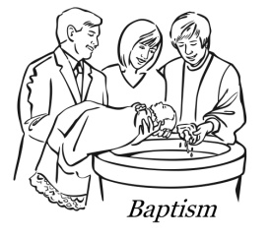
WE WELCOME Luca Frank Macedo into our parish family through the Sacrament of Baptism. We extend our congratulations and prayerful support to his parents and family. A very special welcome to the newest member of our parish family.


EASTER FLOWERS: We hope to have the Church beautifully decorated for Easter in memory of our beloved deceased. Please utilize the Easter Flower envelope found in our special Lenten/Easter mailing which you will be receiving by mail. On the envelope please indicate the name(s) of those you wish to remember. The envelope may be brought to Church or sent to our parish office at your earliest convenience. All names received by Sunday, March 29th will be published in a memorial bulletin for Easter. Thank you so very much for helping us to decorate our beautiful Church for the most important celebration of our faith!


FR. BOB’S REFLECTIONS can still be found on facebook at Holy Trinity Parish Fall River MA or our website at holytrinityparishfallriver.com daily beginning at 7:35am. You may also follow Fr. Bob as he has prepared Stations of the Cross to be viewed on Fridays during Lent.


RELIGIOUS EDUCATION: Classes will be held Sunday, for First Communion class and on-line for grades 3 thru 7.

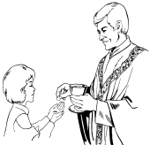
THE SACRAMENT OF THE FIRST EUCHARIST will be celebrated here in our parish on Sunday, May 3rd. Please keep in your prayers the children who will be making their First Communion.

MENTAL HEALTH MINISTRY DIOCESE OF FALL RIVER: Third in a series of what our Faith Community can do to minister to those with mental health and substance use challenges and their families through participation on our Mental Health Ministry team. The dignity of an individual is paramount in our belief that we are all created in the image and likeness of God. As people of compassion and justice we should never use stigmatizing language or demeaning terms when referring to people with an illness. We make the dignity of the individual real by following the example Jesus gave us. It is when we love and extend ourselves to care for those in need that we experience the love that God has for us. If you are interested in being a part of our parish Mental Health Ministry team there will be an informational night on April 8, 2026 at 6:30pm in our Church Hall.

HOLY WEEK & EASTER

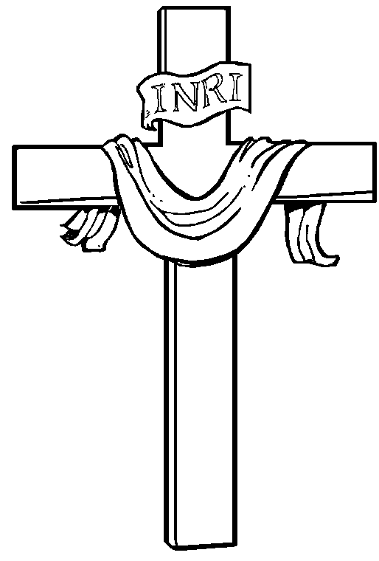

HOLY WEEK IS A VERY SPECIAL TIME FOR THE CHURCH. YOU ARE INVITED TO JOIN US IN THESE SPECIAL LITURGICAL CELEBRATIONS.
The schedule for Holy Week is:

Holy Thursday – Evening Mass of the Lord’s Supper will be celebrated at 7:00pm. Following the solemn Mass, there will be Adoration of the Blessed Sacrament for a brief time in Church.
Good Friday - Solemn Stations of the Cross will take place at 3:00pm. Service of the Passion of the Lord (with the reception of the Holy Eucharist) will be at 7:00pm
Holy Saturday - The Easter Vigil will be celebrated at 7:00pm * please note there will be no Mass at 4:00pm on Holy Saturday.
Easter Sunday - Masses will be celebrated 8:30am and 10:30am
THIS WEEK’S REFLECTION: This is the last full week of Lent. We can feel the conflict and struggle developing in the readings. As we read about the drama that surrounded Jesus’ last days on earth and reflect upon its meaning, we experience how the drama that is going in our own hearts is more intense the closer we get to the end of Lent. The Spirit of the Lord is really trying to help us be more open and more free, to receive the graces our Lord wants to offer us. There is another spirit that is fighting just as hard to distract us, discourage us, and prevent us from being open and attentive to God’s gifts. The closer we get to the mystery of our Lord’s passion, death and resurrection for us, the more we can experience struggle. If I experience myself somewhat “at war” with myself, then these are very important days to keep deliberately asking our Lord to help me. It is also a great time to begin to prepare to renew the baptismal promises at Easter. We can reject the unloving choices we’ve made, all that is unjust, dishonest, disrespectful and violent. We want to refuse to be mastered by an empty promises. Declaring our desire for freedom is a great preparation to receive this great gift. If we have developed the habit of naming a desire the first thing each morning, and carrying on a conversation with our Lord in the brief background moments of the day, we are already comfortable with letting the Word or the Season interact with the concrete events of the week. This way of finding intimacy with our Lord, through our daily interaction - even in a very busy life - is so appropriate for the Fifth Week of Lent. We can discover areas that are still resistant to God’s grace. We can ask for help to practice new ways of being free, or new ways of loving. We can find ways to make financial sacrifices to give to the poor this week. Each night this week, we can give thanks. The closer we get to celebrating Holy Week and the events that brought us our salvation, each of us can express our gratitude, realizing this was all for me.
RELICS OF SAINT JOHN VIANNEY: As part of our diocesan initiative, “Stronger Priests, Stronger Parishes, Stronger Church” we are blessed to welcome relics of Saint John Vianney, the Patron Saint of Priests. The relic is scheduled to be here at Holy Trinity Parish on Sunday, April 5, 2026 thru Monday April 13, 2026. During our hosting period, the relic will be made available in church for veneration and personal prayer. The visit of this relic is more than a moment of devotion – it is a call to consecration.

