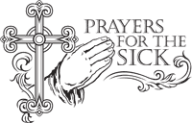
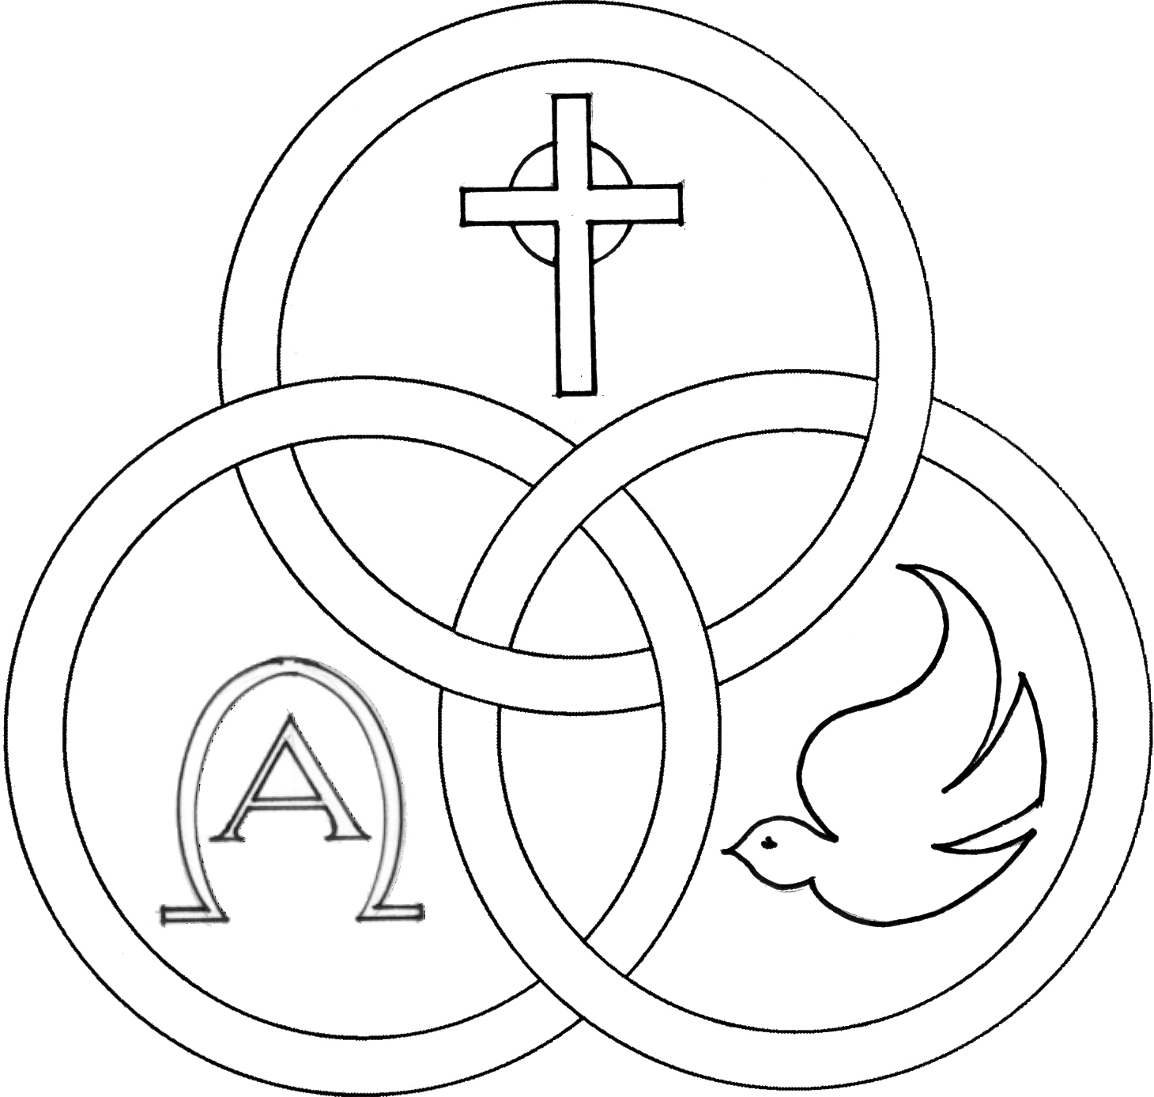
Parish of the Holy Trinity Roman Catholic Church
951Stafford Road
Fall River, Massachusetts
www.holytrinityfallriver.com

Fourth Sunday in Ordinary Time

Saturday 1/31 4th Sunday in Ordinary Time
4:00 pm Barbara & Bill O’Neil & Karen Costa
(by Bill)
Sunday 2/1 4th Sunday in Ordinary Time
8:30 am Henry Furtado (by Family)
10:30 am Maria de Jesus & Antonio Gervasio
(by Daughters)

Monday 2/2 The Presentation of the Lord
8:30 am Albert Roies Jr. 7th Anniversary
(by sister Cindy) .
Tuesday 2/3 Weekday
8:30 am George & Josephine Alves
Wednesday 2/4 Weekday
8:30 am Anna Canuel
Thursday 2/5 Agatha, virgin, martyr
8:30 am For the People of our parish

Saturday 2/7 5th Sunday in Ordinary Time
4:00 pm Michael J. Tremblay (by Wife & Family)
Sunday 2/8 5th Sunday in Ordinary Time
8:30 am Francisco DeAndrade (by Wife)
10:30 am Mary Botelho (by Family)

Blessed Sacrament Sanctuary Lamp:
Given this week in memory of

Maria deJesus
& Antonio Gervasio

By Daughters

Week of 1/25/26

Budget $2,986.21

Latin America $757.00


Yellow registration forms are available on the tables inside Church, near each of the entrances. Please drop them into the collection basket at Mass and introduce yourself to Father Oliveira after Mass or call the parish office for an appointment. We hope that you feel very much at home!
PRAY FOR THE SICK OF OUR PARISH and our families especially for those in hospitals, rehabilitation centers, nursing facilities and the homebound. Pray for all those who are undergoing medical treatments at this time.


THE SECOND COLLECTION
this weekend is the monthly collection for maintenance and expense reduction for our parish. Thank you for all your generosity.


THANK YOU. Thank you for offering $1,602.00 for the school collection and for all you do to help sponsor the beautiful gift of our Catholic School.


HOLY TRINITY YOUTH CHOIR: Next Sunday, February 8th the Holy Trinity Youth Choir will be singing at the 10:30 am Mass.


HOLY TRINITY PARISH SOUP KITCHEN will be held this Thursday, February 5th in our Church Hall. We welcome everyone to come and share a meal with us. Doors open at 5:00pm and close at 6:00pm. Please share the word that all are most welcome to come.


SHOWER FOR THE HOMELESS: In collaboration with the Catholic Social Services of the Fall River Diocese and the Holy Trinity Women's Guild we are collecting NEW ITEMS ONLY; Men, Women and Children; socks, hats, gloves, mittens, scarves, and toiletries. Please place items in the baskets at the entrances of the church. Thank you.


FR. BOB’S REFLECTIONS can still be found on facebook at Holy Trinity Parish Fall River MA or our website at holytrinityparishfallriver.com daily beginning at 7:35am.


RELIGIOUS EDUCATION
Classes will resume this Sunday, February 1st.


THE SACRAMENT OF CONFIRMATION will be celebrated on Tuesday, March 3, 2026 at 6:30 pm here at Holy Trinity by Bishop Edgar da Cunha. Please keep in your prayers all those who are preparing to receive the sacrament of Confirmation.

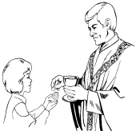
THE SACRAMENT OF THE FIRST EUCHARIST will be celebrated here in our parish on Sunday, May 3rd. Please keep in your prayers the children who will be making their First Communion.


OFFICE OF SAFE ENVIRONMENT All members of the clergy, Directors of Religious Education and teachers in our schools are Mandated Reporters in Massachusetts and required by law to report any suspected child abuse. Many children will not tell anyone they are being abused. Because the Diocese believes in our moral obligation to protect children, we extend the safe environment training to all who minister, work or volunteer. Watch for signs of abuse and, if you are concerned about a child, share those concerns with a mandated reporter at your parish or school. Let us all be a voice for children who may not be able to speak for themselves.

EXCITING NEWS FROM THE ANCHOR: The Anchor, the long standing newspaper of Diocese of Fall River, is transitioning from a paid monthly print edition to a free weekly electronic newsletter. Signing up is simple. Visit www.bit.ly//Anchornewsletter or the diocesan website, fallriverdiocese.org, and provide your name and e-mail address. Stay informed and stay connected with all the news and events in Diocese plus the latest developments in the Catholic Church across the country and around the world. Look for the first Anchor newsletter in mid February along with a new and enhanced Anchor website.

THIS WEEK’S REFLECTION: This is a wonderful week to use the brief background times of our lives to talk with the Lord about our need for healing. We can begin each day by naming some desire we have for healing and deeper wholeness and peace. Putting these desires into words, early each day, as soon as we get up or while in the shower or while dressing, helps us give focus to our relationship with the Lord that day. “Lord, thank you for this day. Be with me as I face the challenges before me today. I especially need patience and more compassion, Lord. Heal the anger I feel, and give me peace, so that I can love the way I know you want me to.” Each of us can make this 30 second prayer specific to what we need to do each day, and what graces we need to do it. Getting in the habit of naming what I need and asking for it will shape how we spend the day, confidently aware of our God ’s presence with us. Throughout the day, we can continue our simple conversation with our Lord, speaking friend to friend. We may encounter some spirits within ourselves that aren’t very clean. Anger or resentment, fear or paralysis, jealousy or pride, lust or greed, self-pity or judging of others are all spirits that distort our ability to love others the way we are loved by our God. When we encounter them, we can ask the Lord to heal us, to drive these spirits from our hearts. Each experience of our need for a Savior can deepen our desire, and our ability to name them each morning. The healing stories in the gospels make it clear that faith is key to the healing. When the people in Jesus’ home town say, “Isn’t this just the carpenter’s son?” their lack of faith is saying, “He can’t heal us.” In our own struggle with letting Jesus be our Savior, two things can get in the way. First of all, we need to know we need healing. Secondly, we need to want to be healed. If I cling to being angry or have become comfortable being afraid, I will first need to acknowledge what a difference freedom would mean in my life and come to desire healing. Then, I need to believe our Lord can heal me. The rest is easy. This honest dialogue with our Lord, throughout our days, no matter what we are doing, can help us grow in faith in the One who wants nothing more than to keep freeing us to know his love for us and to share it generously with others. The integrating element of this daily prayer is the gratitude we express each evening before we sleep, giving thanks for the grace to be able to connect with our Savior throughout this busy day.

